**Practical 1**

**Aim: -** Familiarization with networking components and devices

* Hubs / Repeaters
* Switches
* Bridges
* Routers

**Hubs: -**

A hub is a small, rectangular, inexpensive device that joins together multiple network-enabled devices. They're often made of plastic and receive power from an ordinary wall outlet.

The purpose of a hub is to join multiple computers or other network devices together to form a single network segment. On this network segment, all devices can communicate directly with each other.

Ethernet hubs vary in their speed (network data rate, or bandwidth). Original Ethernet hubs were rated at just 10 Mbps, but modern ones have 100 Mbps support and usually offer both 10 Mbps and 100 Mbps capabilities (known as *dual-speed* or *10/100* hubs).

The number of ports an Ethernet hub supports also varies. Four- and five-port Ethernet hubs are most common in-home networks, but eight- and 16-port hubs can be found in some home and small office environments.

Hubs can be connected to each other this is called daisy chaining. It is used to expand the total number of devices a hub network can support.

For daisy chaining connect one end of a cable to a port on one Hub and the other end to a port on the other Hub. On some hubs, a special designated port is used for daisy chaining.

Types of hubs:

* *Passive hubs* don't amplify the electrical signal of incoming packets before broadcasting them out to the network.
* *Active hubs* perform amplification, much like a repeater.

|  |  |
| --- | --- |
|  | HUBS  HUB |

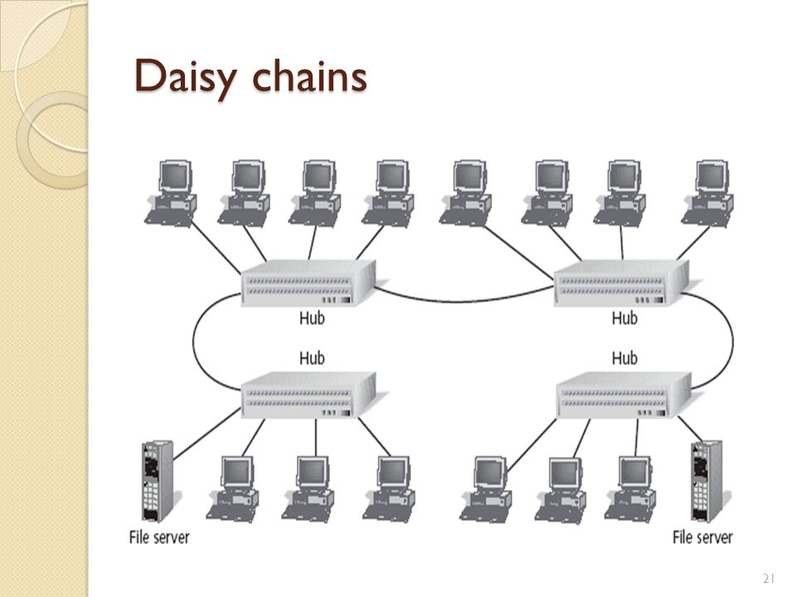

**Switches: -**

A network switch (also called switching hub, bridging hub, officially MAC bridge) is a computer networking device that connects devices together on a computer network by using packet switching to receive, process, and forward data to the destination device.

A network switch is a multiport network bridge that uses hardware addresses to process and forward data at the data link layer (layer 2) of the OSI model. Some switches can also process data at the network layer (layer 3) by additionally incorporating routing functionality. Such switches are commonly known as layer-3 switches or multilayer switches.

Switches for Ethernet are the most common form of network switch. The first Ethernet switch was introduced by Kalpana in 1990. Switches also exist for other types of networks including Fiber Channel, Asynchronous Transfer Mode, and InfiniBand.

Unlike less advanced repeater hubs, which broadcast the same data out of each of its ports and let the devices decide what data they need, a network switch forwards data only to the devices that need to receive it.

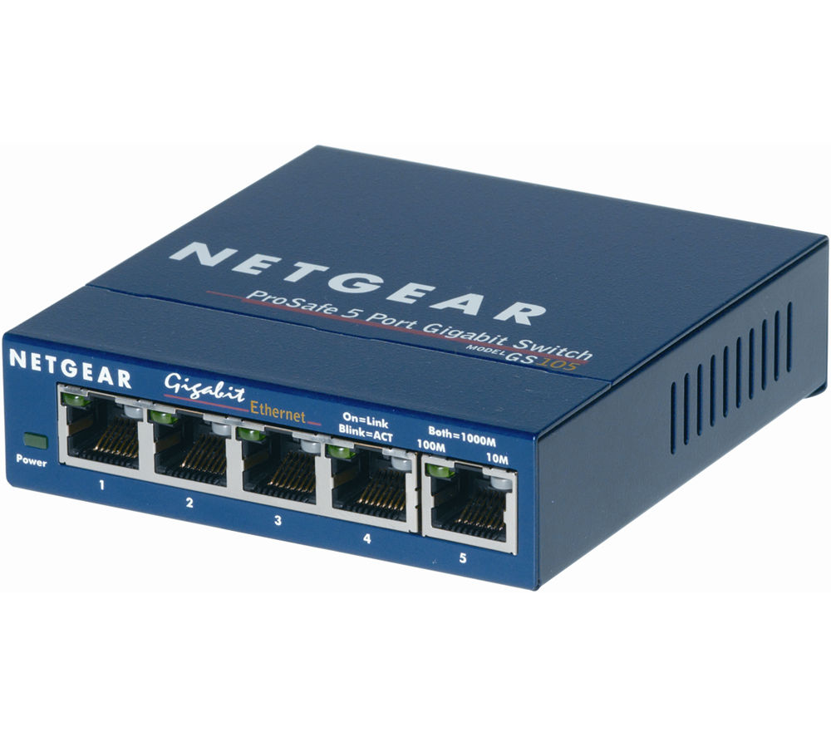

**Bridges: -**

A bridge is a type of computer network device that provides interconnection with other bridge networks that use the same protocol.

Bridge devices work at the data link layer of the Open System Interconnect (OSI) model, connecting two different networks together and providing communication between them. Bridges are similar to repeaters and hubs in that they broadcast data to every node. However, bridges maintain the media access control (MAC) address table as soon as they discover new segments, so subsequent transmissions are sent to only to the desired recipient.

Bridges are also known as Layer 2 switches.

A network bridge device is primarily used in local area networks because they can potentially flood and clog a large network thanks to their ability to broadcast data to all the nodes if they don’t know the destination node's MAC address.

A bridge uses a database to ascertain where to pass, transmit or discard the data frame.

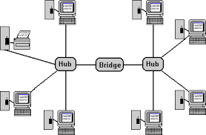

**Routers: -**

A router is a device that analyzes the contents of data packets transmitted within a network or to another network. Routers determine whether the source and destination are on the same network or whether data must be transferred from one network type to another, which requires encapsulating the data packet with routing protocol header information for the new network type.

When several routers are used in a collection of interconnected networks, they exchange and analyze information, and then build a table of the preferred routes and the rules for determining routes and destinations for that data. As a network interface, routers convert computer signals from one standard protocol to another that's more appropriate for the destination network.

Large routers determine interconnectivity within an enterprise, between enterprises and the Internet, and between different internet service providers (ISPs); small routers determine interconnectivity for office or home networks. ISPs and major enterprises exchange routing information using border gateway protocol (BGP).

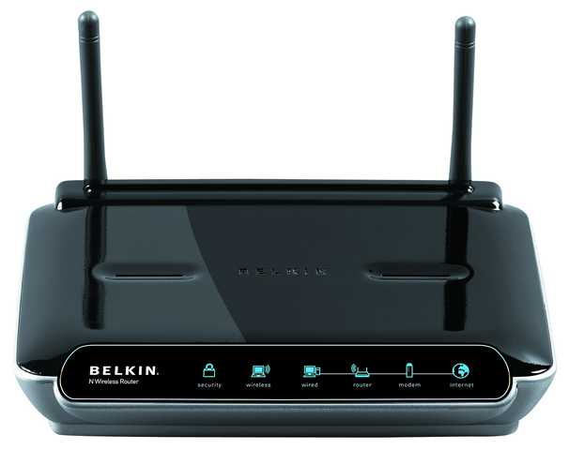

**Practical 2**

**Aim: -** Introduction to cables and connectors

**Network and Communication Cables**

Network and communication cables are network hardware used to connect one network device to other network devices. For example, connecting two or more computers to share printers and scanners; connecting several severs to an access switch. The range covers data and Ethernet cable assemblies, including twisted pair cable, coaxial cable, optical fiber cable, power line, etc. The twisted pair cable, coaxial cable and optical fiber cable are categories that are most often referred to.

Optic Fiber cables and connectors

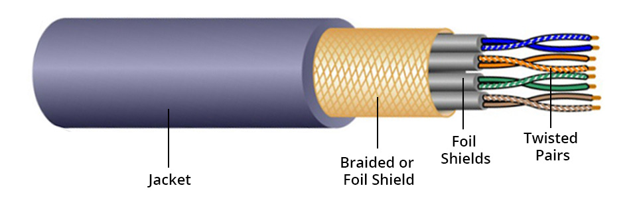

Twisted pair cables are often shielded in an attempt to prevent electromagnetic interference. Twisted pair with shielding are known as shielded twisted pair (STP). In contrast to STP, unshielded twisted pair (UTP) is not surrounded by any shielding.

STP cable is also divided by overall shield and individual shield. Individual shielded twisted pair is with aluminum foil for each twisted pair or quad. This type of shielding protects cable from external electromagnetic interference (EMI) entering or exiting the cable and also protects neighboring pairs from crosstalk. Overall shielded twisted pair is with overall foil or braided shield across all of the pairs within the 100 Ω twisted pair cable. This type of shielding helps prevent EMI from entering or exiting the cable. One STP cable can have both overall and individual shielding.

UTP cable without shielding is more prone to outside interference. For this reason, this cable type is more often found in indoor telephone applications. Outdoor telephone cables contain hundreds or thousands of pairs. Pairs that have the same twisted rate within the cable can experience some degree of crosstalk, so wire pairs are usually selected carefully within a large cable to reduce the crosstalk.

Most UTP cable uses RJ45 connectors, which look like telephone connectors (RJ11) but have eight wires instead of four.

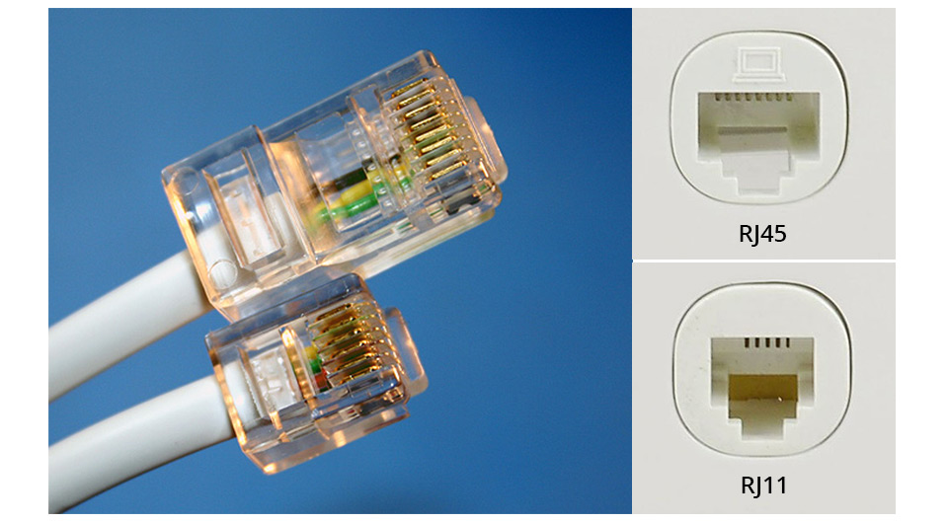

**Coaxial Cable:**

Coaxial cable is a type of cable that has an inner conductor surrounded by a tubular insulating layer, surrounded by a tubular conducting shield. The inner conductor and the outer shield share a geometric axis. Many coaxial cables have an insulating outer sheath or jacket.

Coaxial cable is used as a transmission line for radio frequency (RF) signals. Its applications include feedlines connecting radio transmitters and receivers with their antennas, computer network connections, digital audio, and distributing cable television signals. Coaxial cable has an obvious advantage over other types of radio transmission line. In a good coaxial cable, the electromagnetic field carrying the signal exists only in the space between the inner conductor and the outer conducting shield. For this reason, coaxial cables are allowed to be installed next to metal objects without power losses that occur in other types of radio transmission line.

Many coaxial connector types are available in the audio, digital, video, RF and microwave industries, each designed for a specific purpose and application. One consideration the number of connect-disconnect cycles that a connector pair could withstand while still performing as expected. Here are some common coaxial connector types.

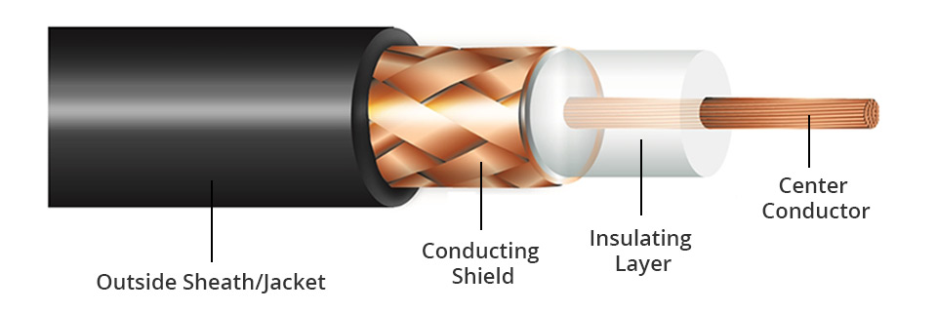

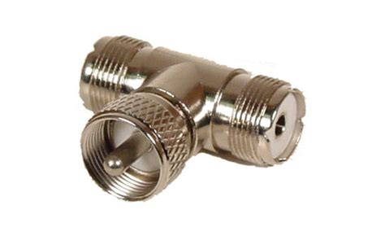

**Optical Fiber Cables**

Optical fiber cabling is an excellent transmission medium for its high data capacity and supported long distances. It is indispensable in any fiber optic network. It has a fiber/glass core within a rubber outer coating and uses beams of light rather than electrical signals to relay data. Because light doesn't diminish over distance the way electrical signals do, this cabling can run for distances measured in kilometers with transmission speeds from 10 Mbps up to 100 Gbps or higher.

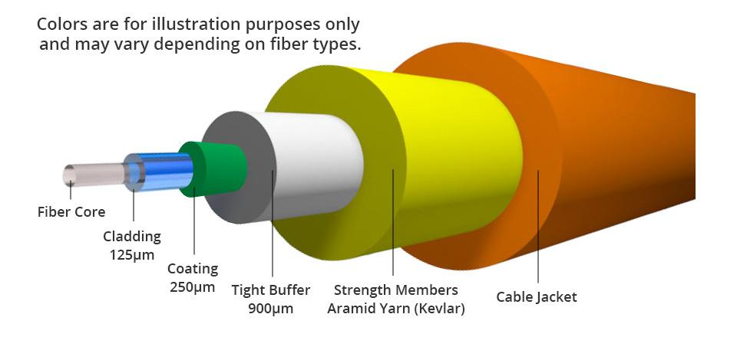

The inner fiber can be either single mode or multimode. Generally, a single mode fiber core is 9/125µm wide, whereas a multimode fiber core can be 62.5/125µm or 50/125µm wide. Only the early OM1 is 62.5/125µm fiber, the later generations OM2, OM3, OM4, OM5 50/125µm fiber. The letters “OM” stand for optical multimode. Both multimode fiber (MMF) and single mode fiber (SMF) can be used for high-speed transmission. MMF is often for short reach while SMF is for long reach.

Fiber optic cables connectors

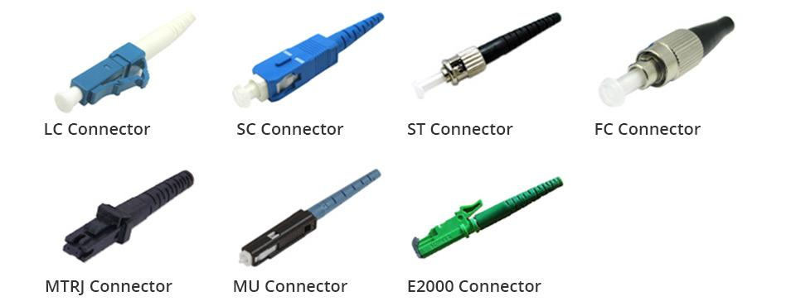

**Practical 3**

**Aim: -** How to use crimping tool on twisted pair cable and RJ45 connector

**What Is Straight-Through Cable?**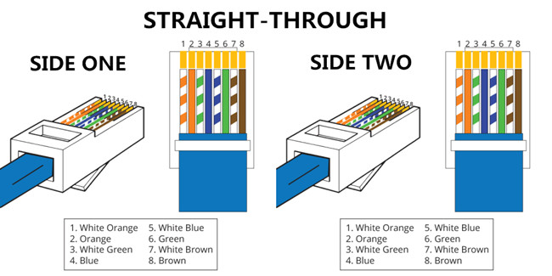

A straight-through cable is a type of twisted pair cable that is used in local area networks to connect a computer to a network hub such as a router. This type of cable is also sometimes called a patch cable and is an alternative to wireless connections where one or more computers access a router through a wireless signal. On a straight-through cable, the wired pins match. Straight-through cable use one wiring standard: both ends use T568A wiring standard or both ends use T568B wiring standard. The following figure shows a straight-through cable of which both ends are wired as the T568B standard.

**What Is Crossover Cable?**

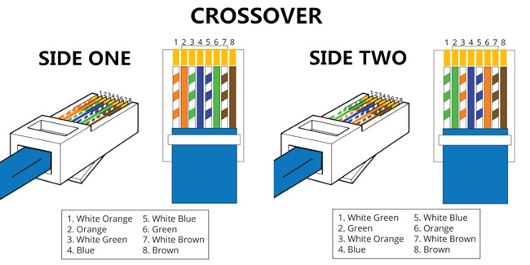

An Ethernet crossover cable is a type of Ethernet cable used to connect computing devices together directly. Unlike straight-through cable, crossover cables use two different wiring standards: one end uses the T568A wiring standard, and the other end uses the T568B wiring standard. The internal wiring of Ethernet crossover cables reverses the transmit and receive signals. It is most often used to connect two devices of the same type: e.g. two computers (via network interface controller) or two switches to each other.

Straight Cable

* Both side T568A or T568B

Cross Cable

* One side T568A and another side T568B

**Difference between straight-through and crossover cables**

Straight-through and crossover cables are wired differently from each other. One easy way to tell what you have is to look at the order of the colored wires inside the RJ45 connector. If the order of the wires is the same on both ends, then you have a straight-through cable. If not, then it’s most likely a crossover cable or was wired wrong. At present, the straight-through cable is much more popular than crossover cable and is widely used by people.

**Different Cabling Schemes: -**

|  |  |
| --- | --- |
| T568A   * White Green * Green * White Orange * Blue * White Blue * Orange * White Brown * Brown   T568B   * White Orange * Orange * White Green * Blue * White Blue * Green * White Brown * Brown |  |

Steps for crimping twisted pair cables

* Get cable and your RJ-45 connectors.
* Strip 1 to 2 inches (2.5 to 5.1 cm) of the outer skin at the end of the cable wire by making a shallow cut in the skin with a utility knife.
* Fold each pair of wires backwards to expose the core of the cable.
* Cut off the core and discard.
* Straighten the twisted wires using 2 pair of tweezers.
* Arrange the untwisted wires in a row, placing them into the position, running from right to left, in which they will go into the RJ-45 connector:
* Trim the untwisted wires to a suitable length by holding the RJ-45 connector next to the wires.
* Insert the wires into the RJ-45 connector, making sure that they stay aligned and each color goes into its appropriate channel.
* Use the crimping tool to crimp the RJ-45 connector to the cable by pressing the jacket and cable into the connector so that the wedge at the bottom of the connector is pressed into the jacket.
* Follow the instructions above to crimp an RJ-45 connector to the opposite end of the cable.
* Use a cable tester to assure that your cable is working properly when both ends are crimped.

Crimping Tool



**Practical 4**

Commands

* Ping
* Ipconfig
* traceroute
* netstat

**PING :**

The ping command is a Command Prompt command used to test the ability of the source computer to reach a specified destination computer. The ping command is usually used as a simple way to verify that a computer can communicate over the network with another computer or network device.

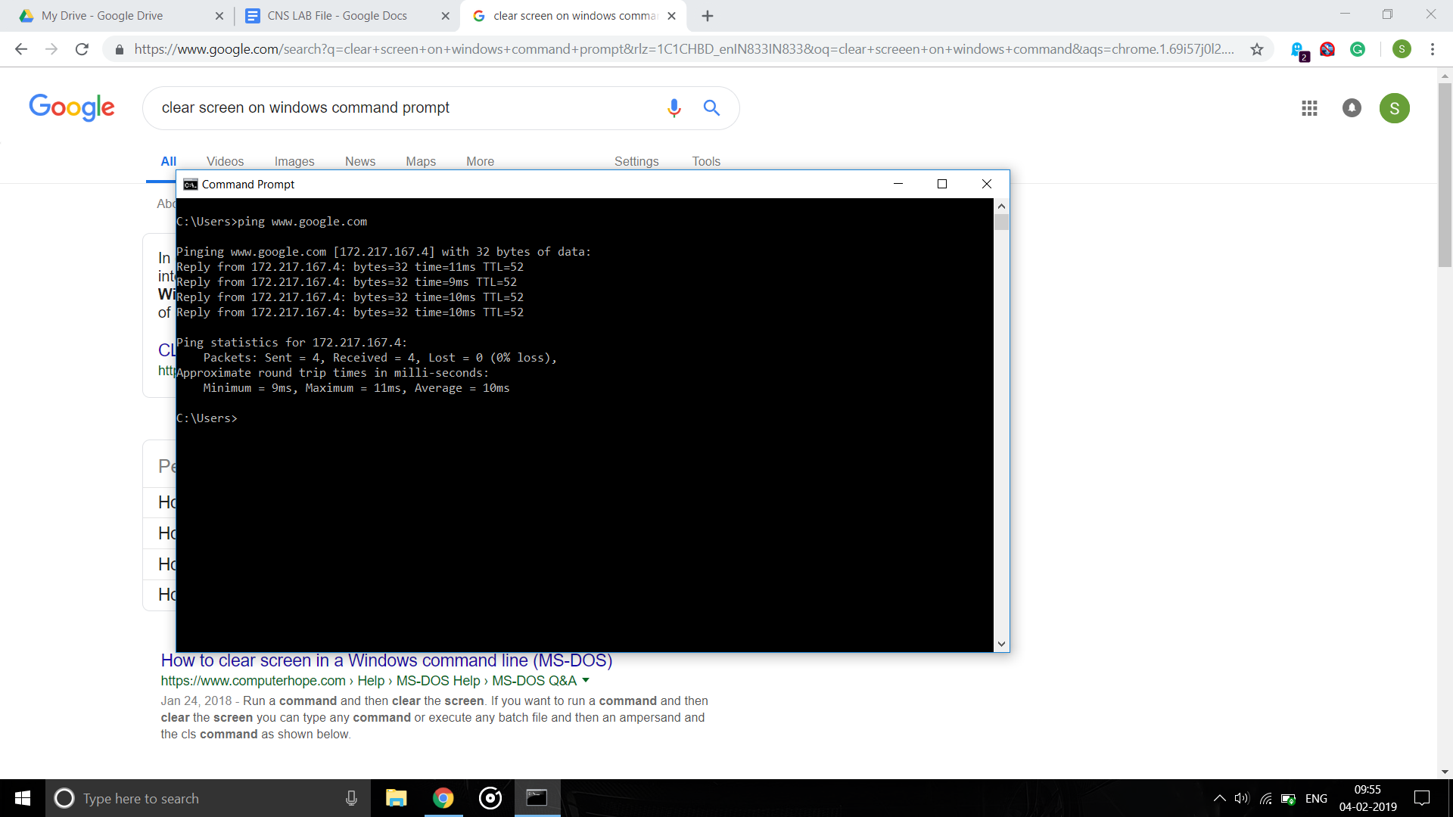

**Ping /? : Show ping options**

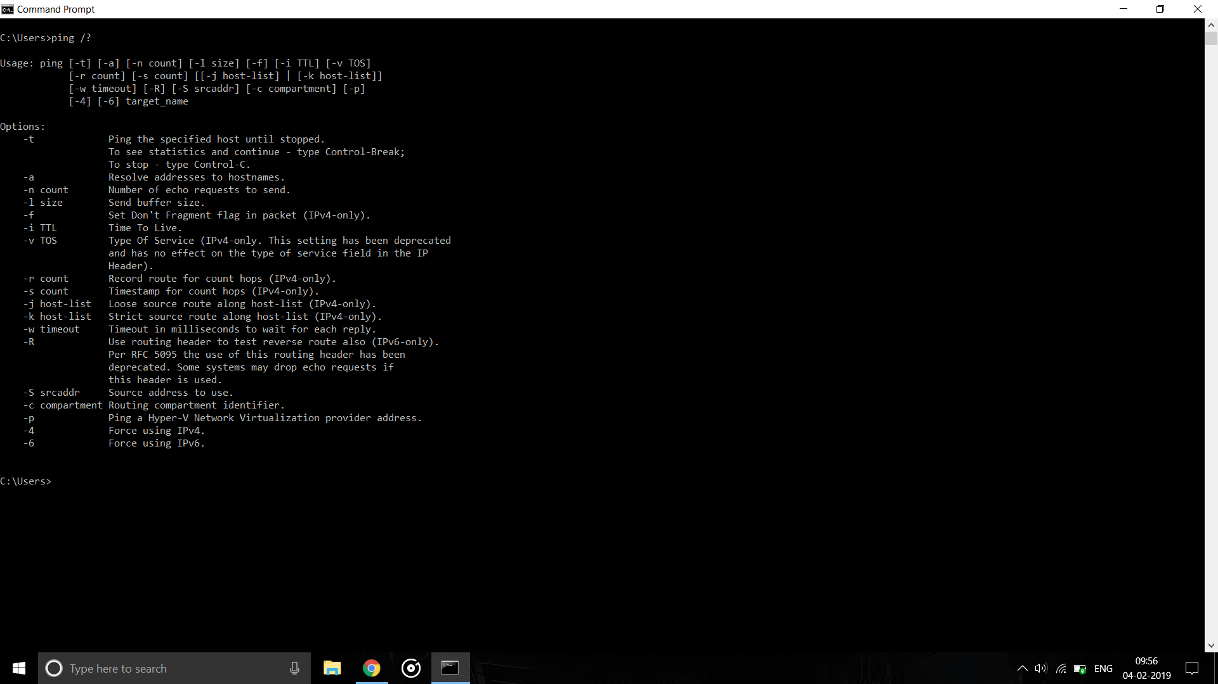

**-t : Ping the specified host until stopped**

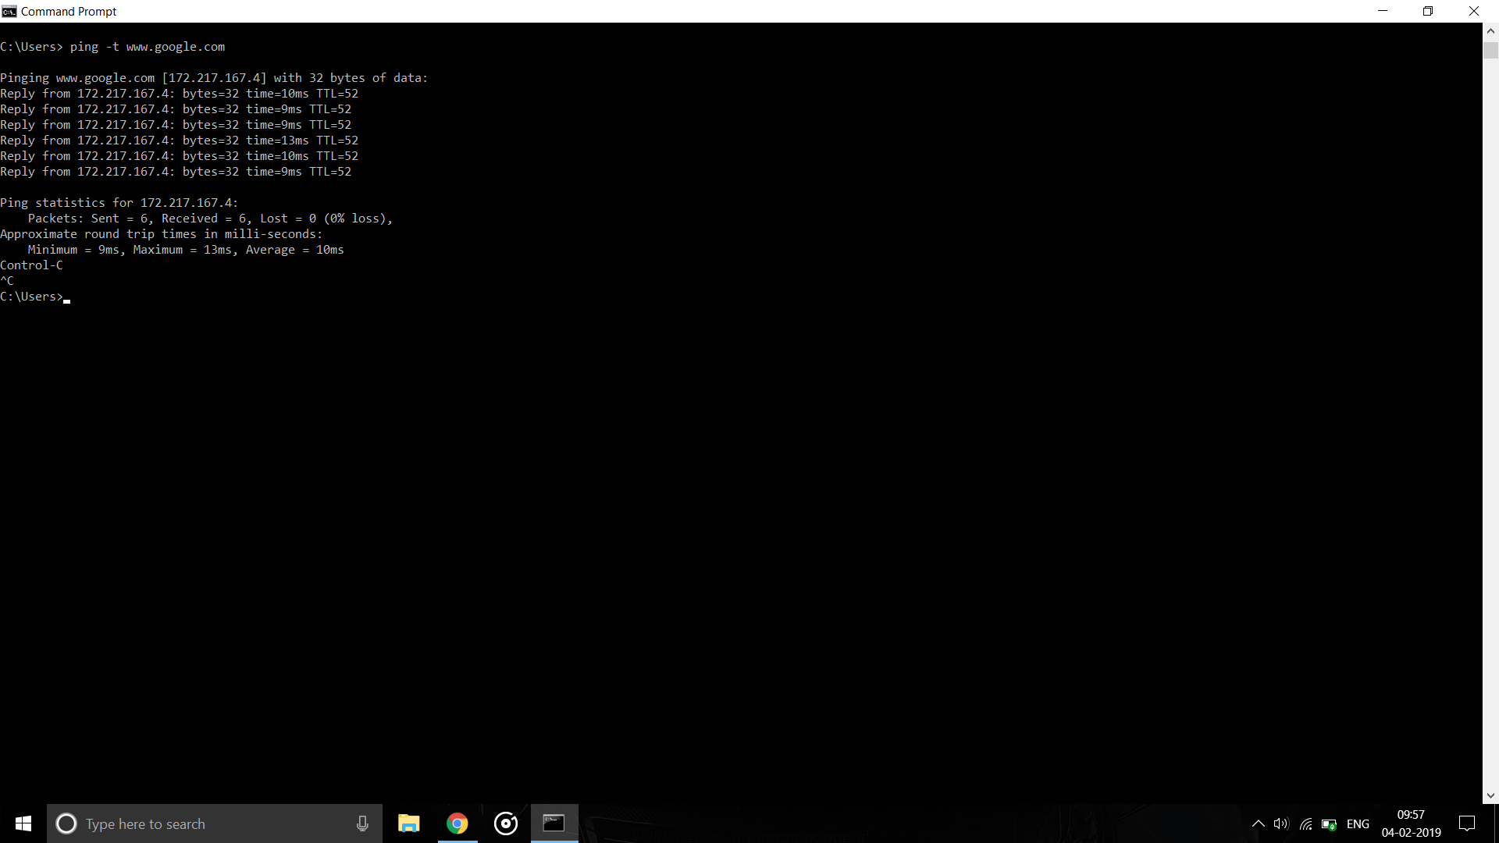

**-f : Set don’t fragment bit (for IPv4)**

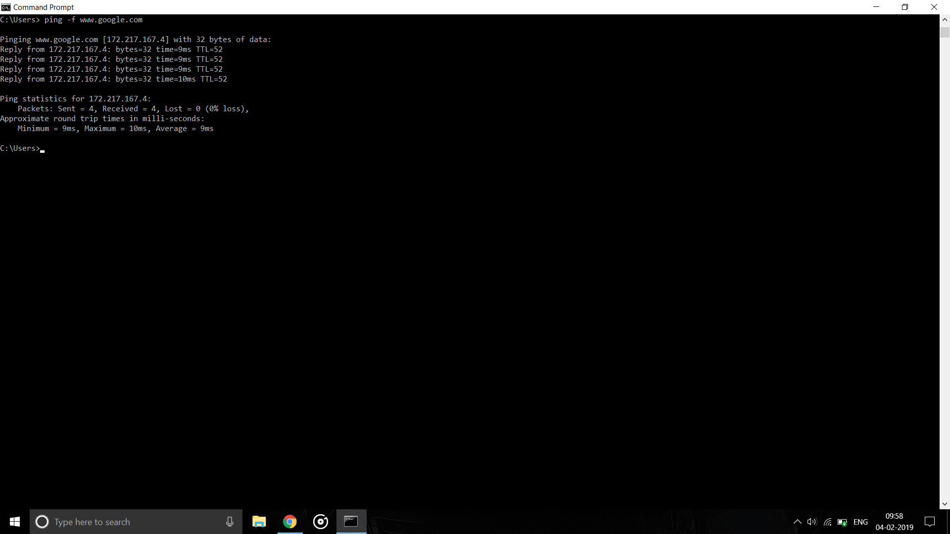

**-l size : Send buffer size**

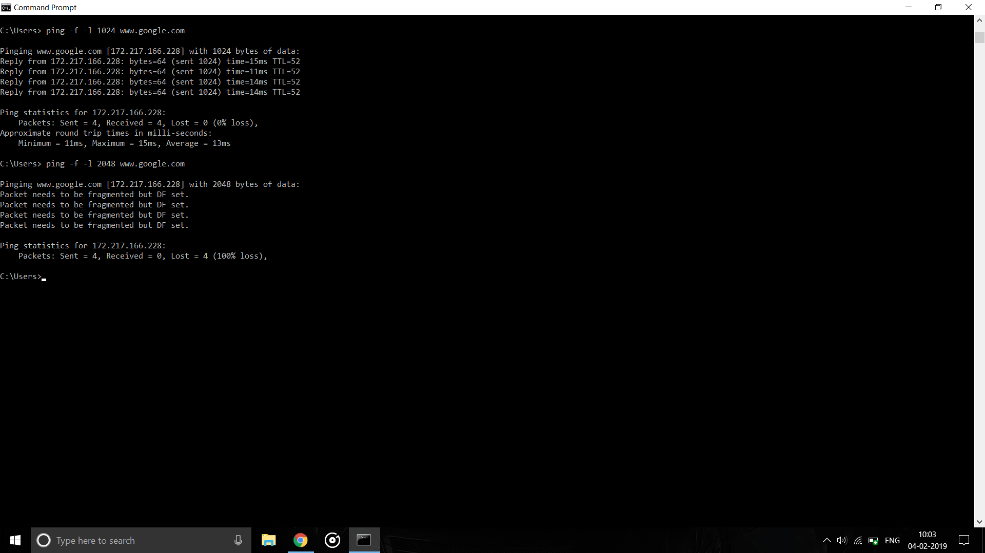

**-n count : number of echo requests to send.**

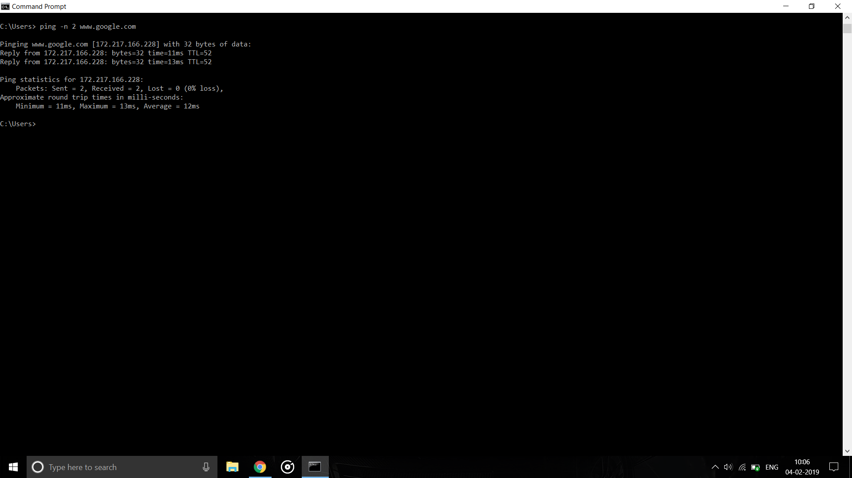

**-i TTL : Set Time To Live (TTL)**

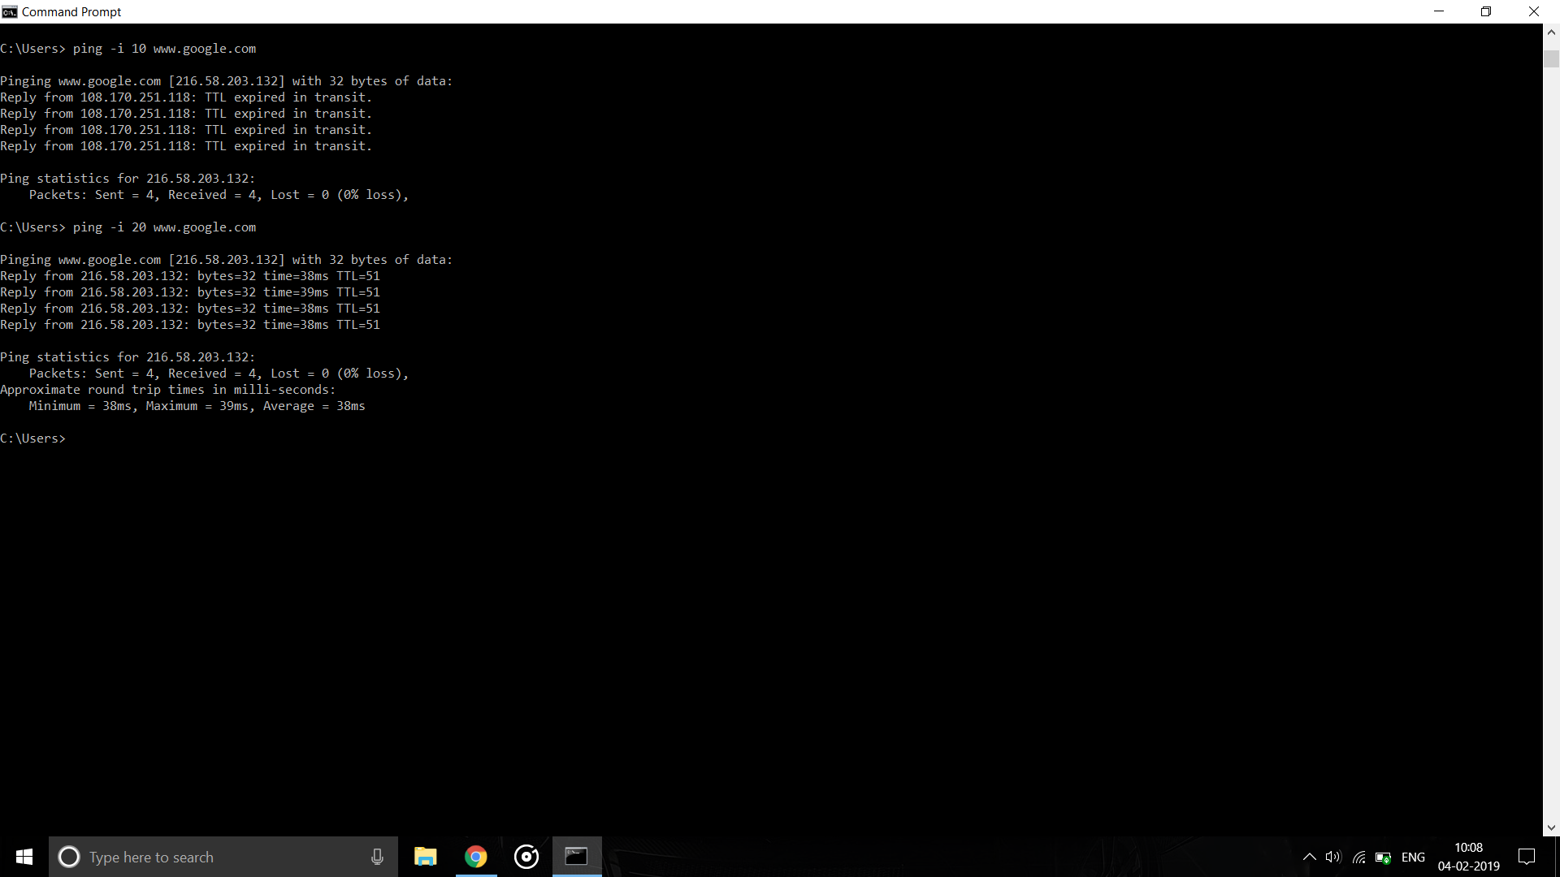

**-r count : Record route for count hops (IPv4-only).**

**-s count : Timestamp for count hops (IPv4-only).**

**-w : Timeout in milliseconds to wait for each reply.**

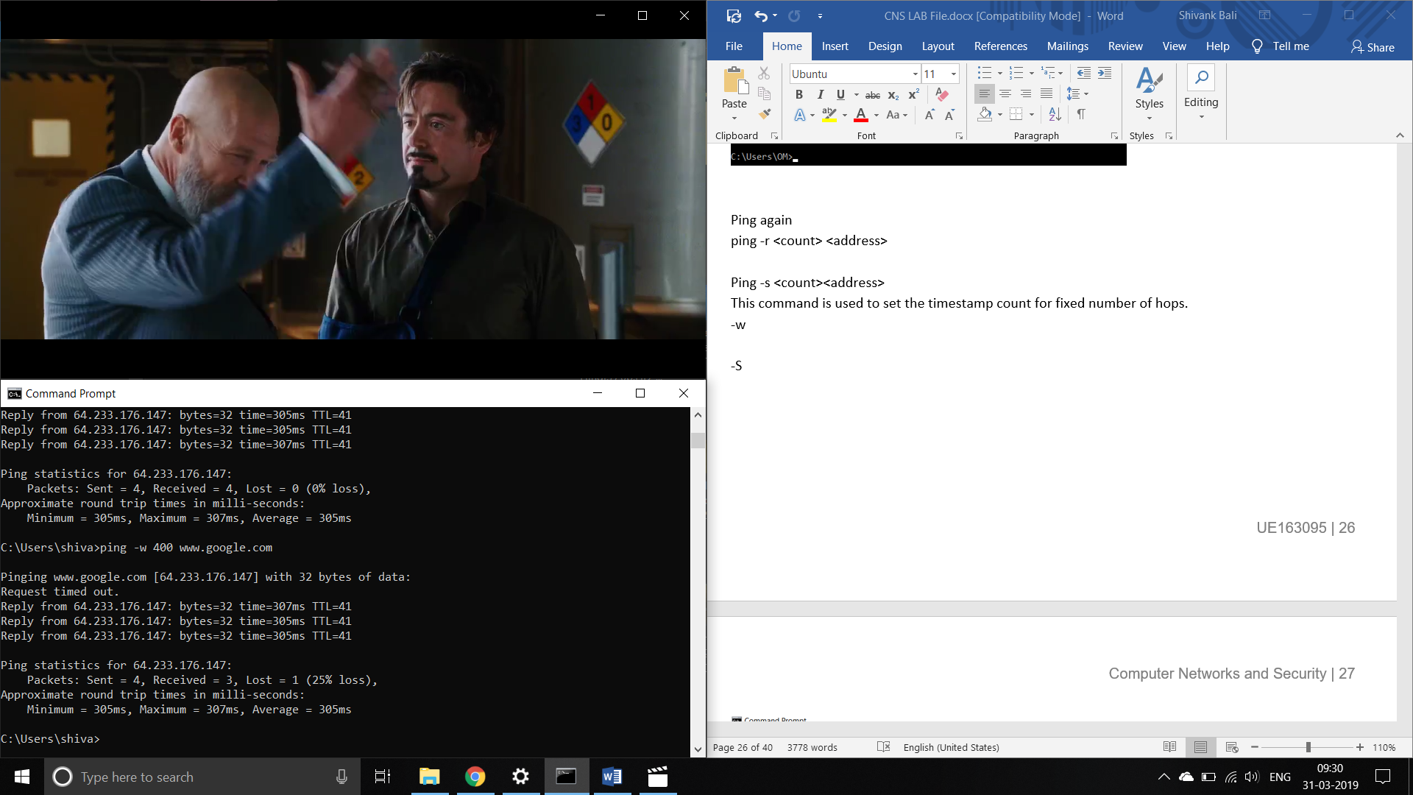

**-S srcaddr : Source address to use.**

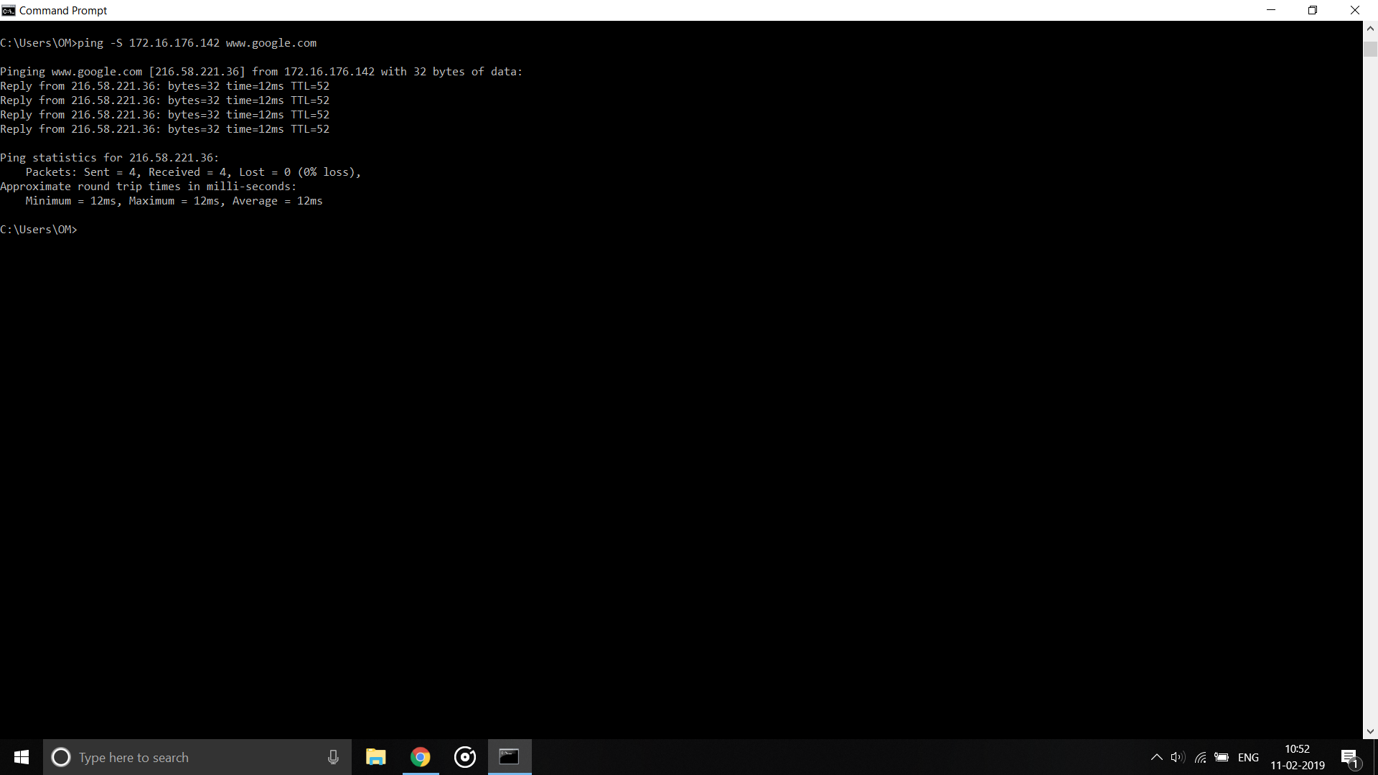

**-4 : Force using IPv4**

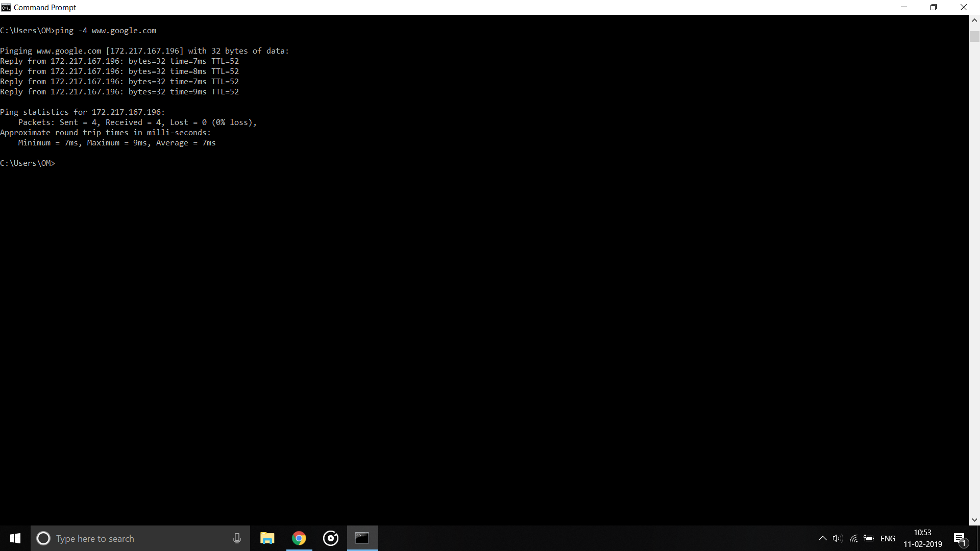

**Ipconfig :**

Ipconfig is a console application designed to run from the Windows command prompt. This utility allows you to get the IP address information of a Windows computer. It also allows some control over active TCP/IP connections. Ipconfig replaced the older winipcfg utility.

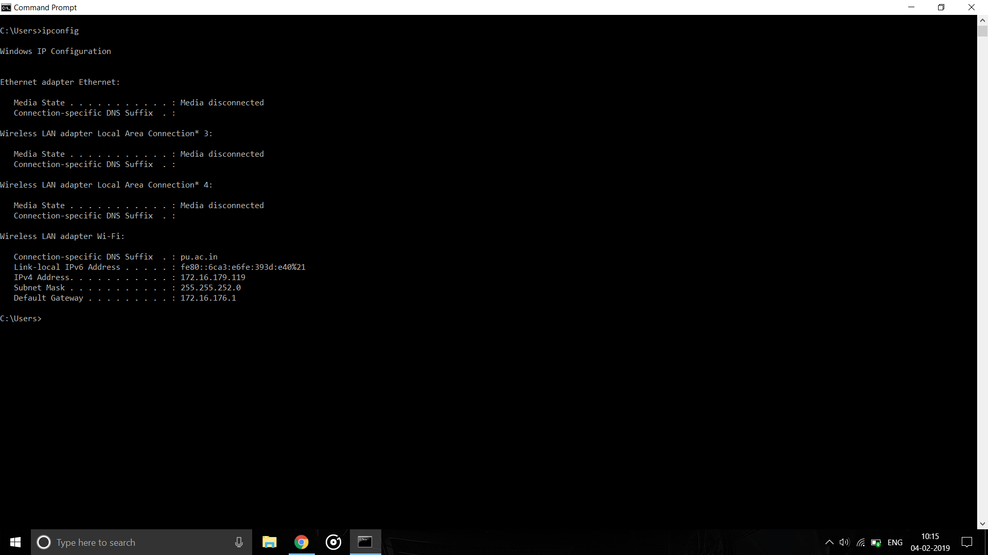

**ipconfig /all : Display full configuration information**

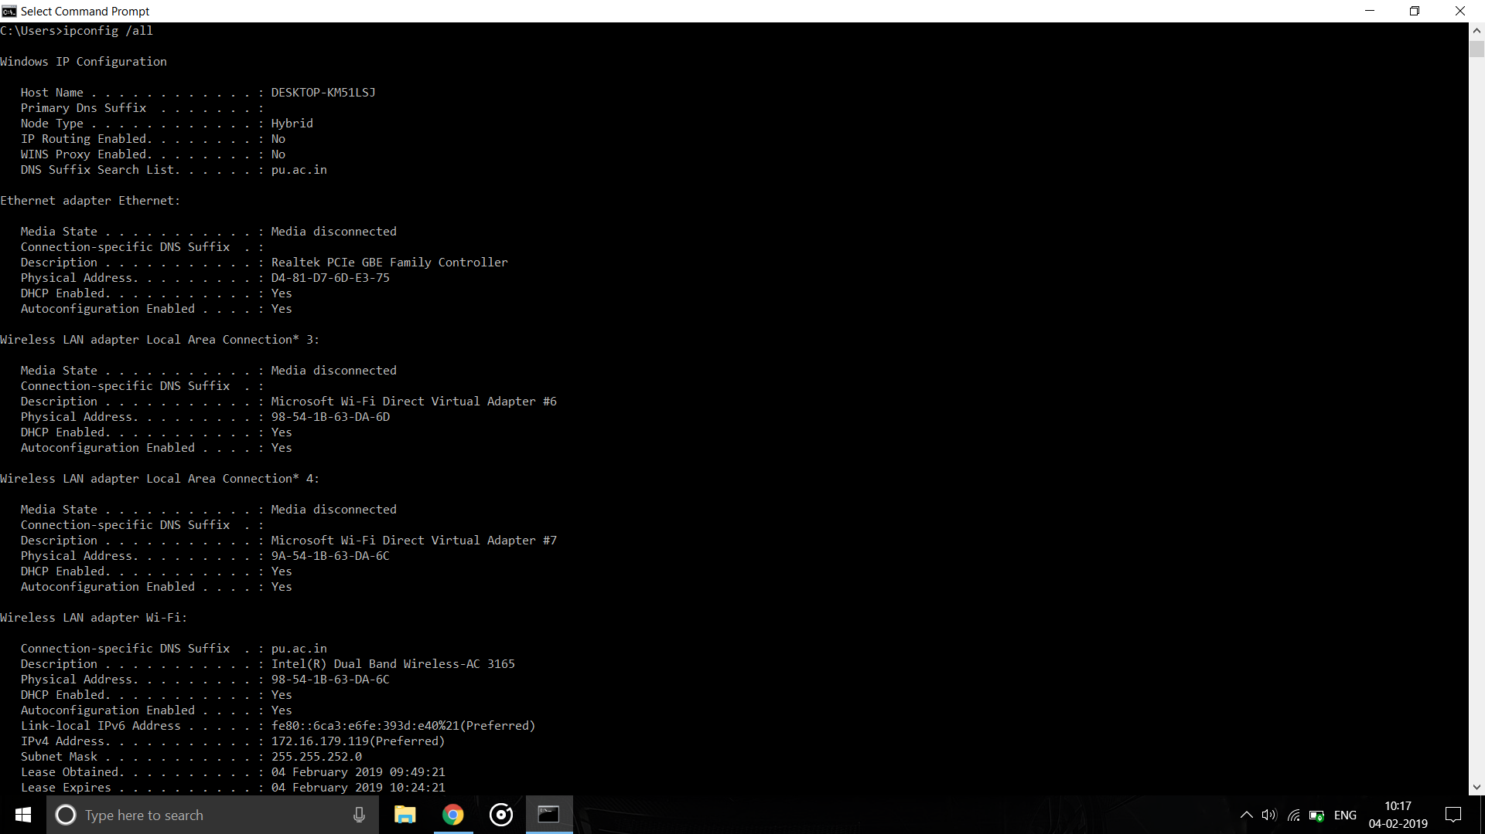

**Ipconfig /renew : Renew the IPv4 address for the specified adapter.**

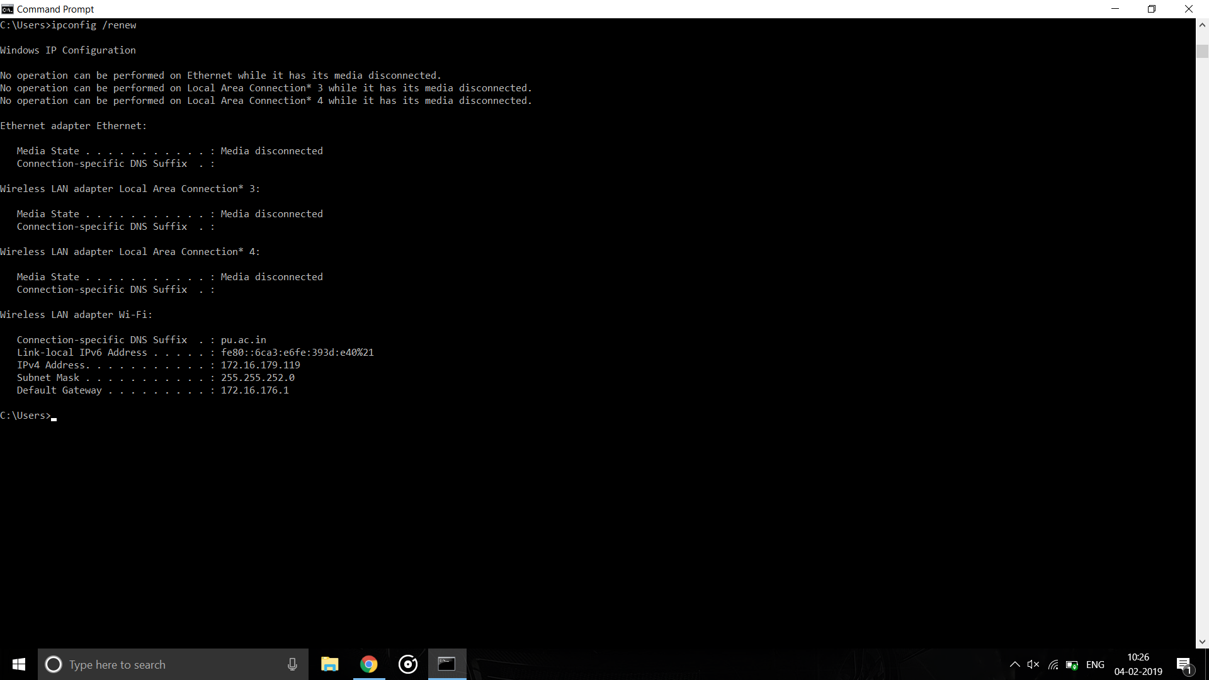

**ipconfig /release : Release the IPv4 address for the specified adapter.**

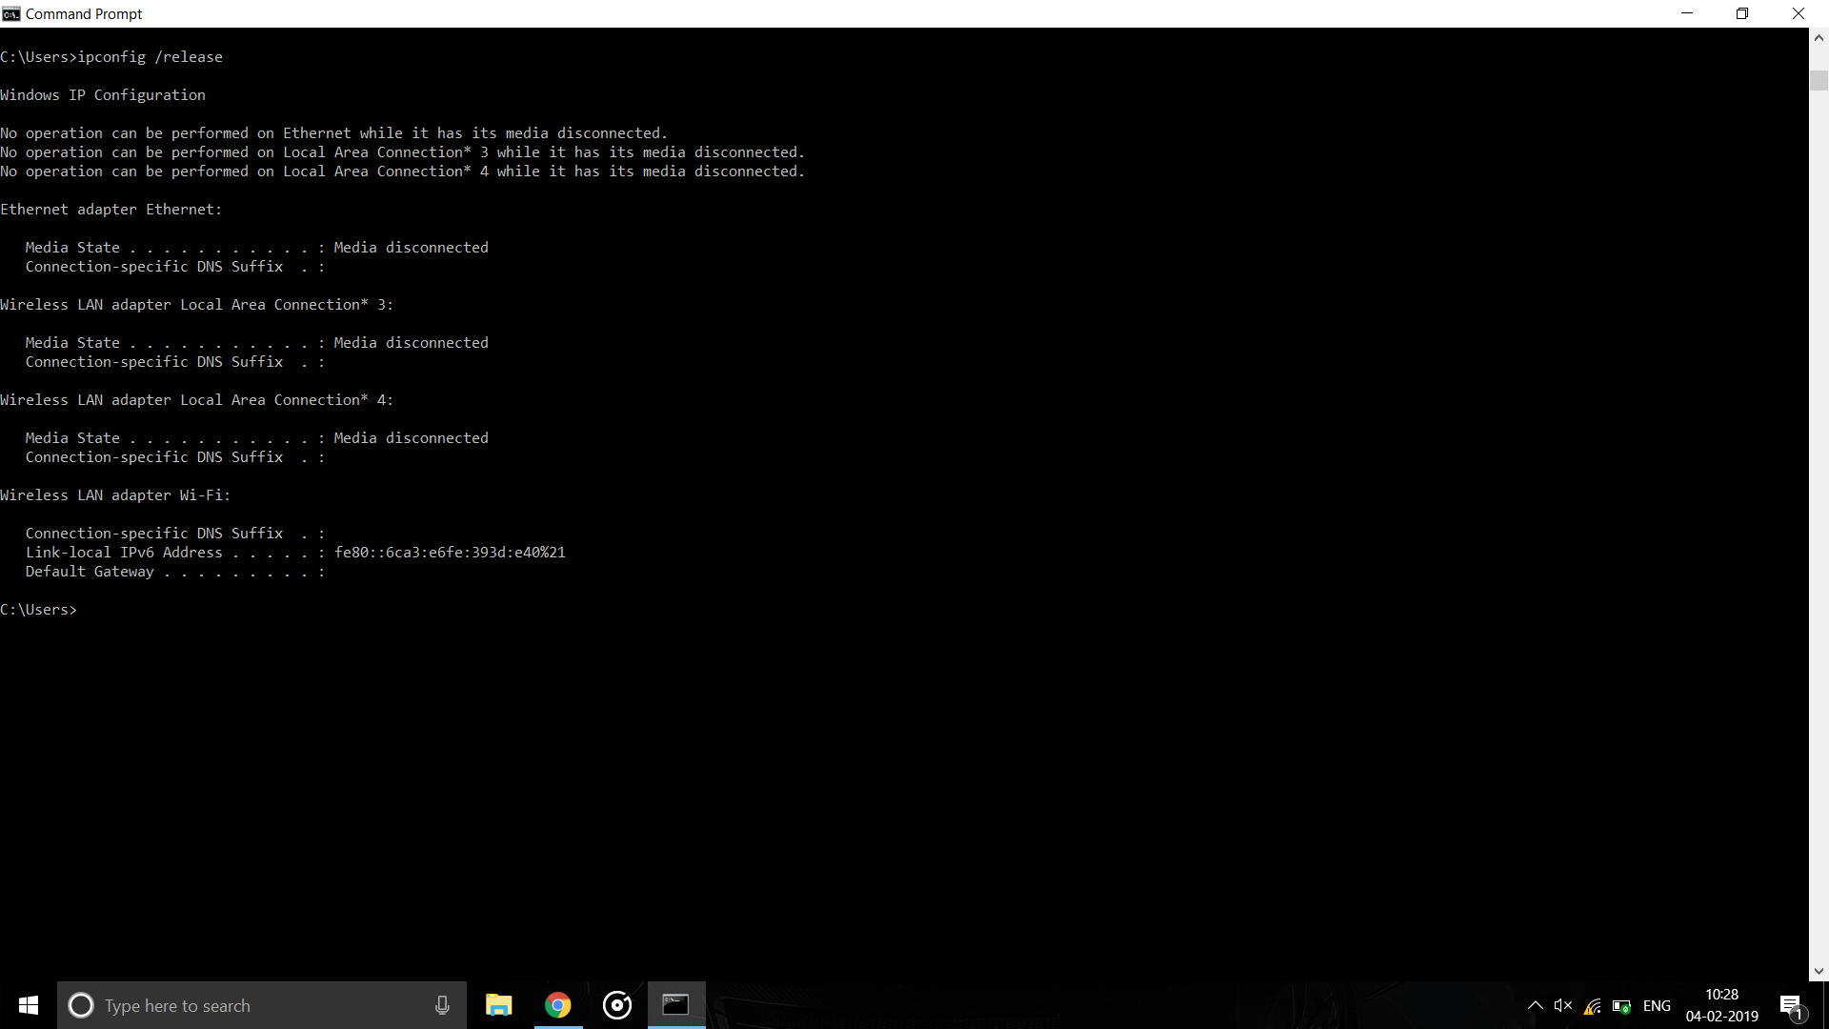

**ipconfig /flushdns : Purges the DNS Resolver cache.**

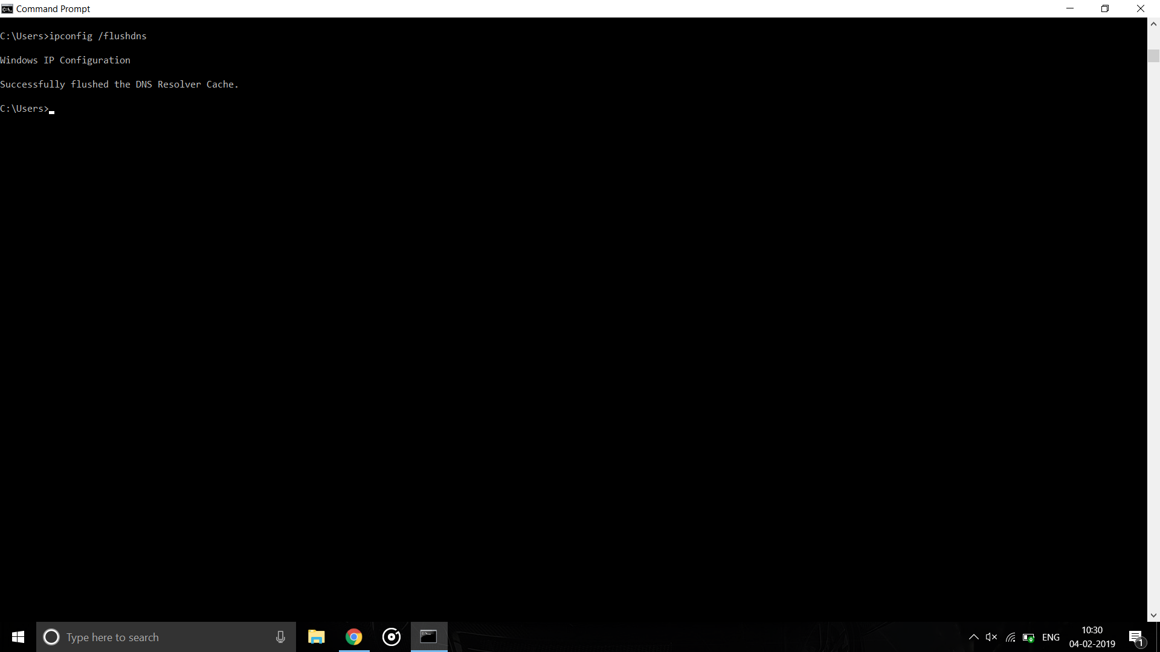

**Tracert :**

The tracert command is a Command Prompt command that's used to show several details about the path that a packet takes from the computer or device you're on to whatever destination you specify.

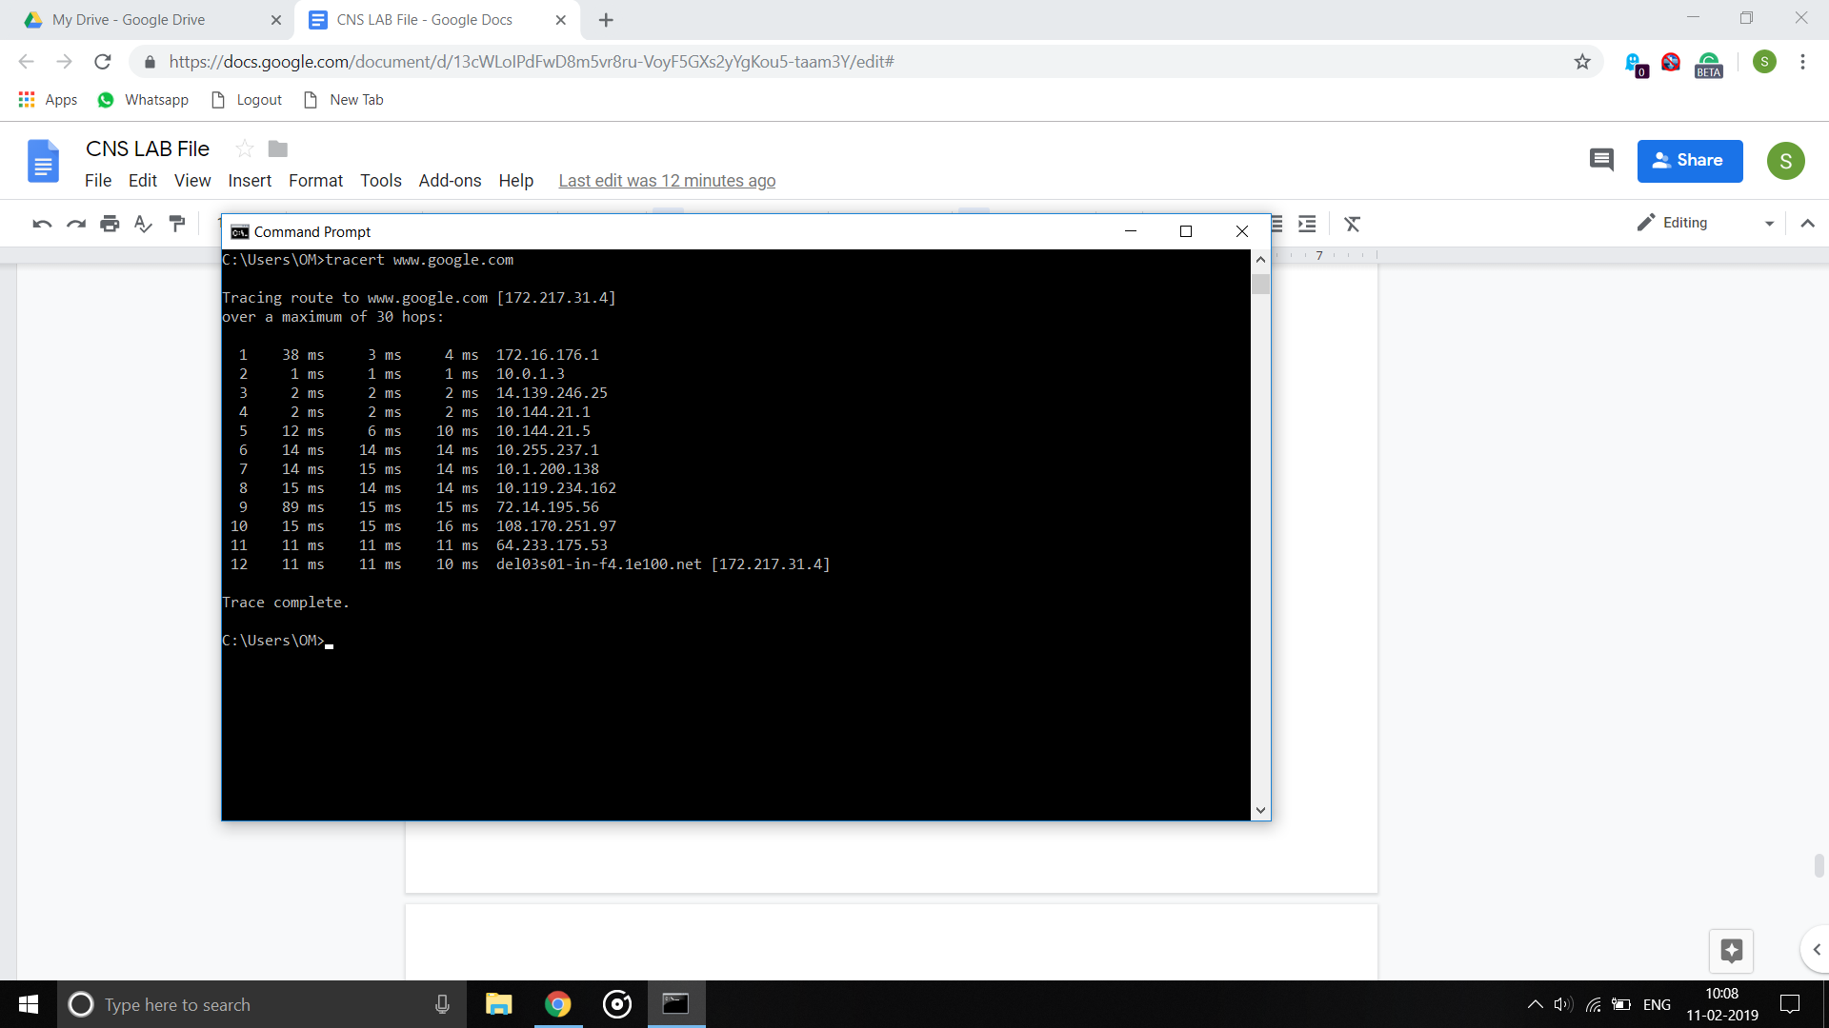

**-h maximum hops : Maximum number of hops to search for target.**

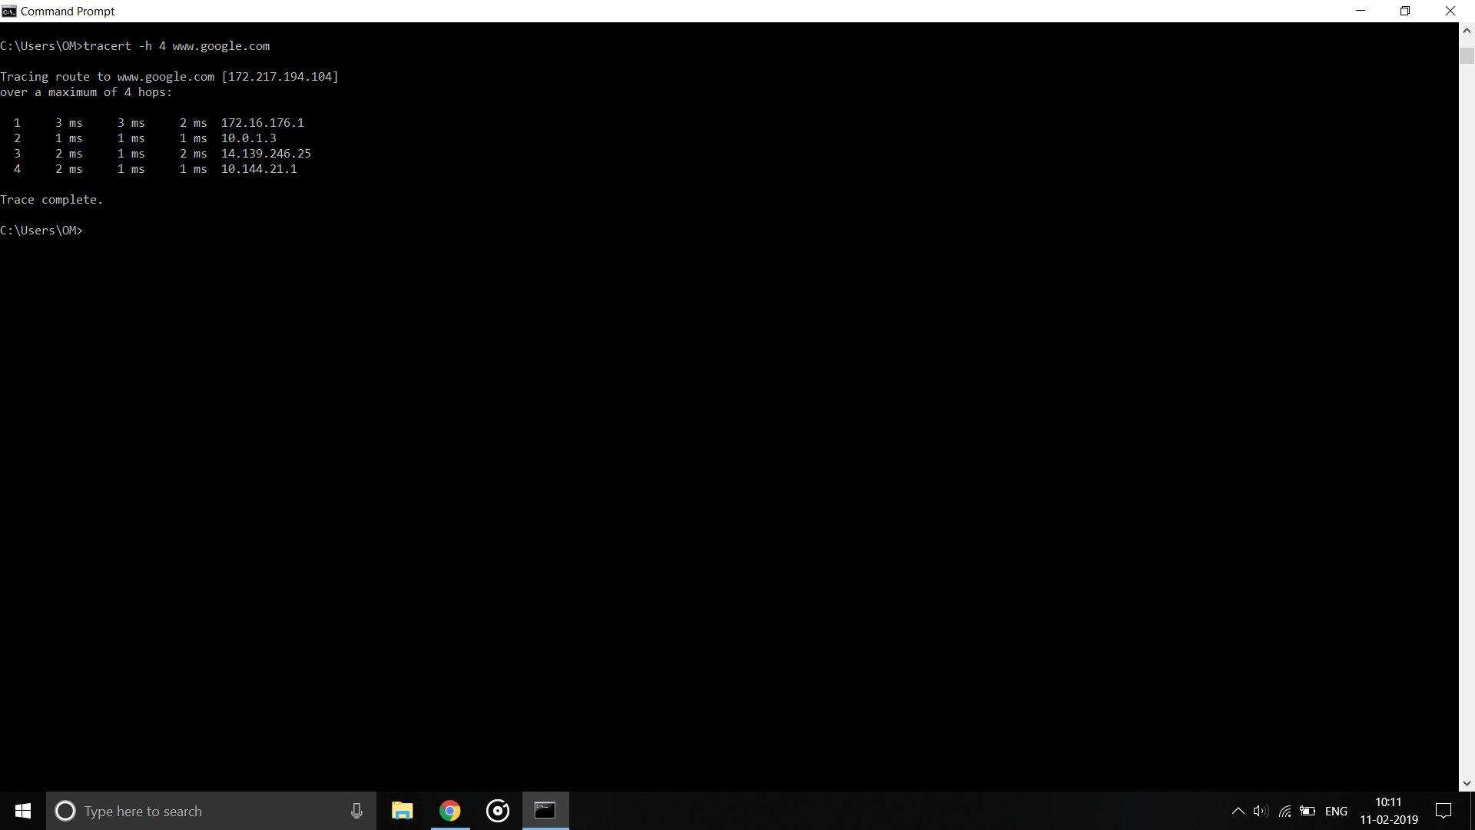

**-d : Do not resolve addresses to hostnames.**

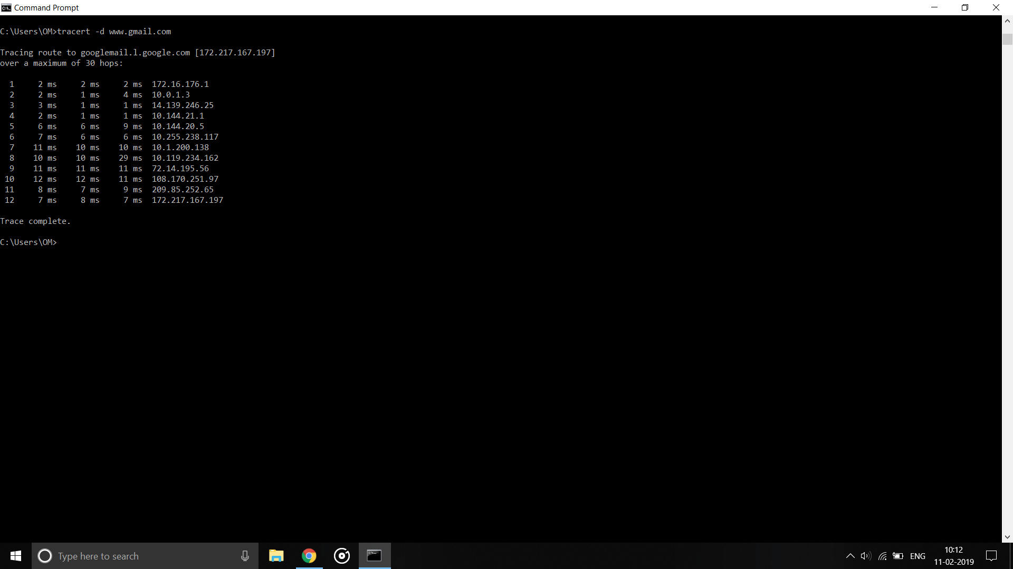

**Netstat :**

The netstat command, meaning network statistics, is a Command Prompt command used to display very detailed information about how your computer is communicating with other computers or network devices.

Specifically, the netstat command can show details about individual network connections, overall and protocol-specific networking statistics, and much more, all of which could help troubleshoot certain kinds of networking issues.

**-a : Displays all connections and listening ports.**

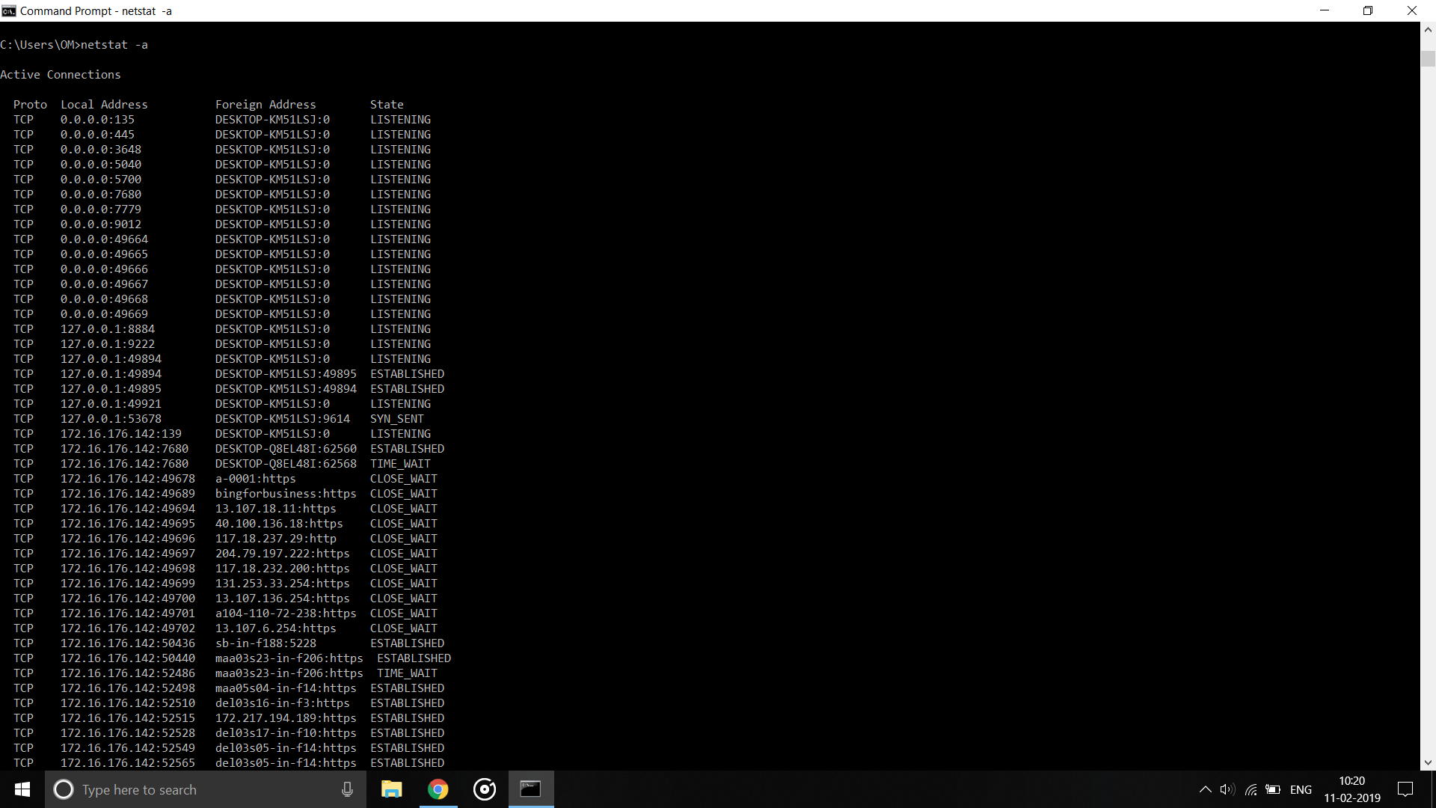

**-n : Displays addresses and port numbers in numerical form.**

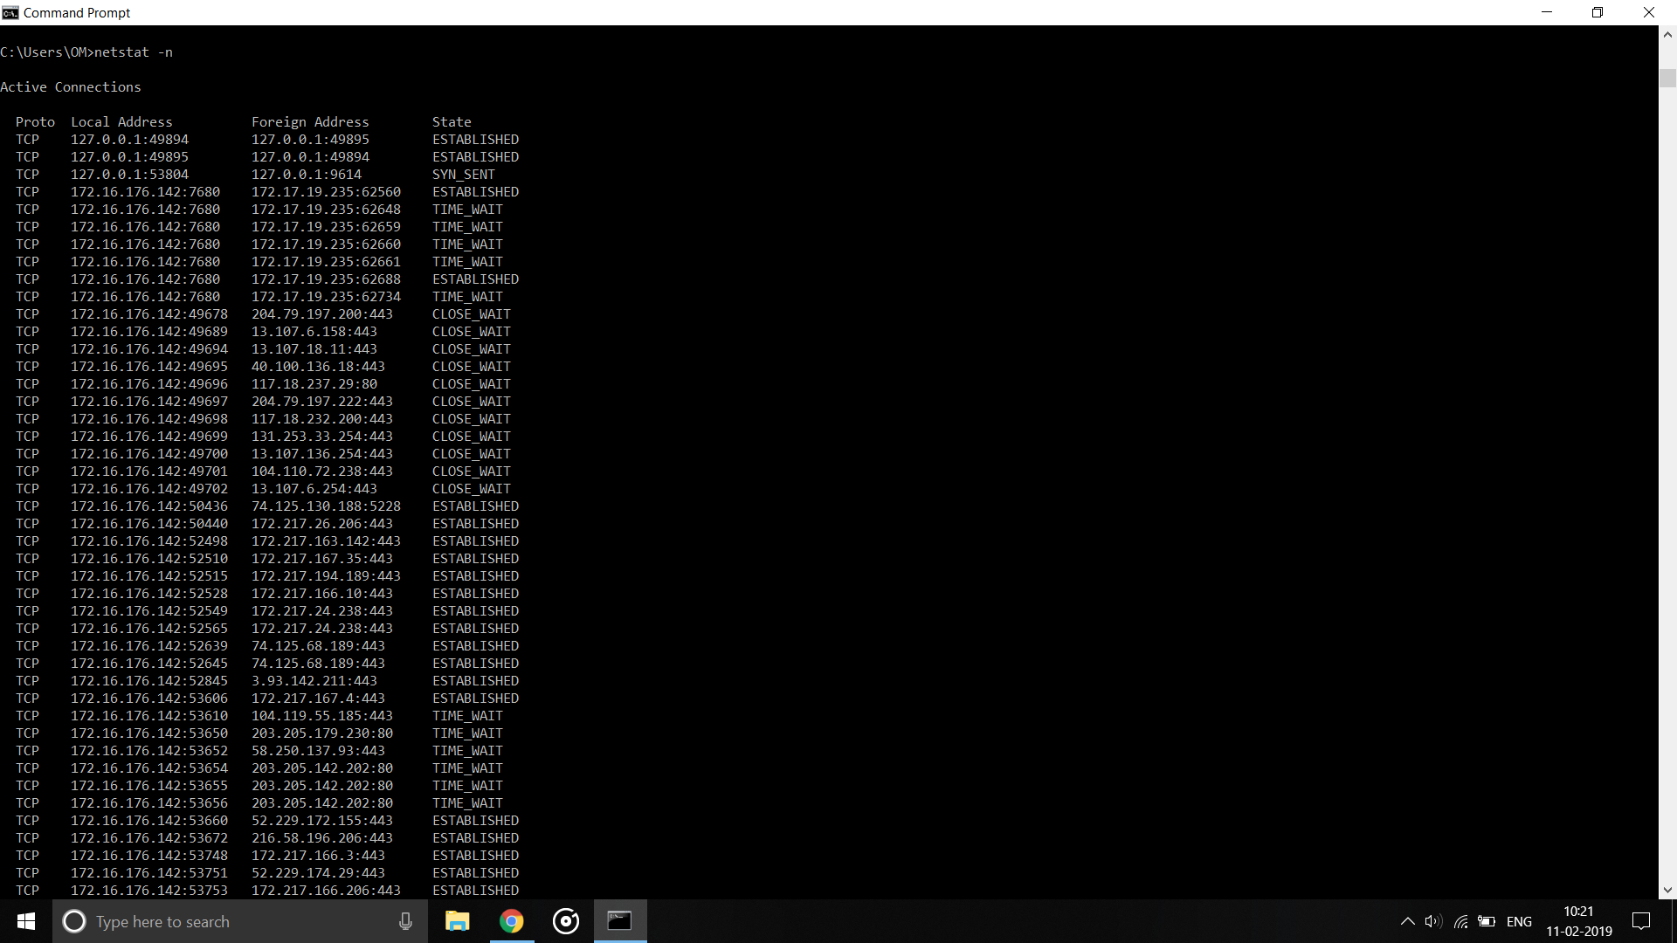

**-e : Displays Ethernet statistics.**

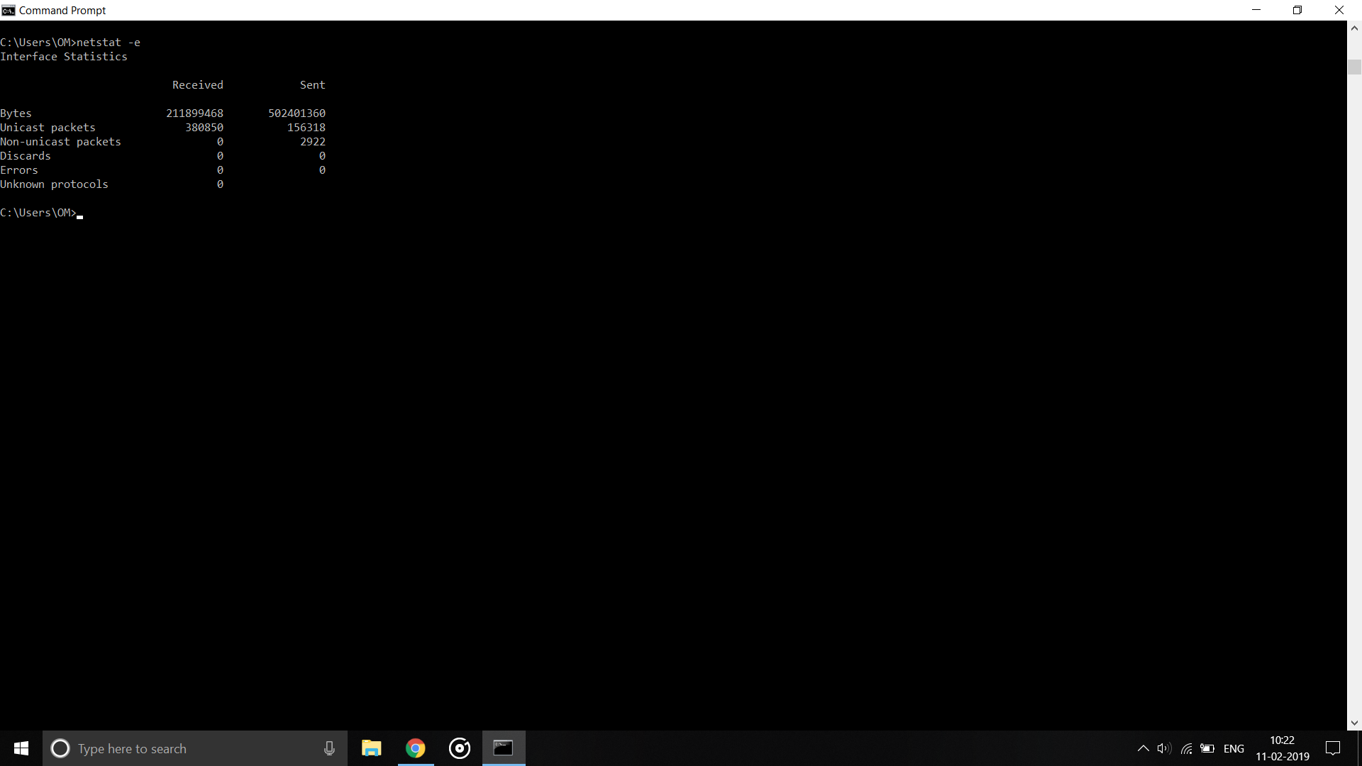

**-f : Displays Fully Qualified Domain Names (FQDN) for foreign addresses.**

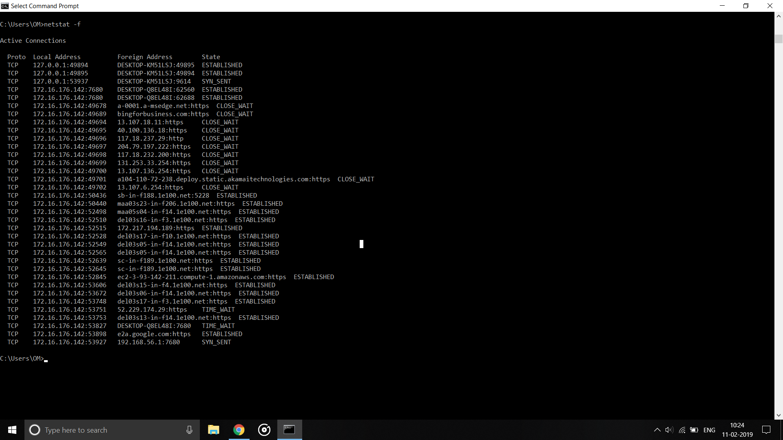

**-o : Displays the owning process ID associated with each connection.**

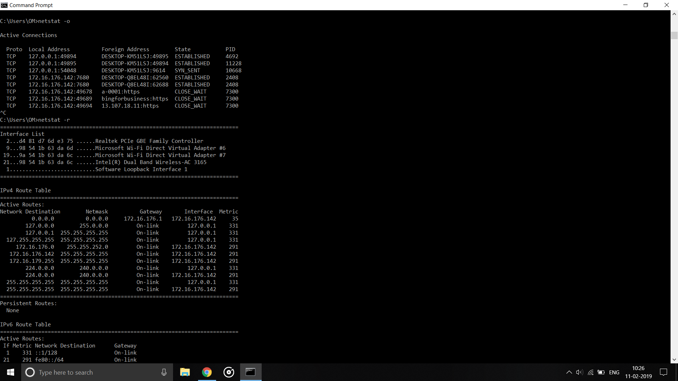

**-r : Displays the routing table.**

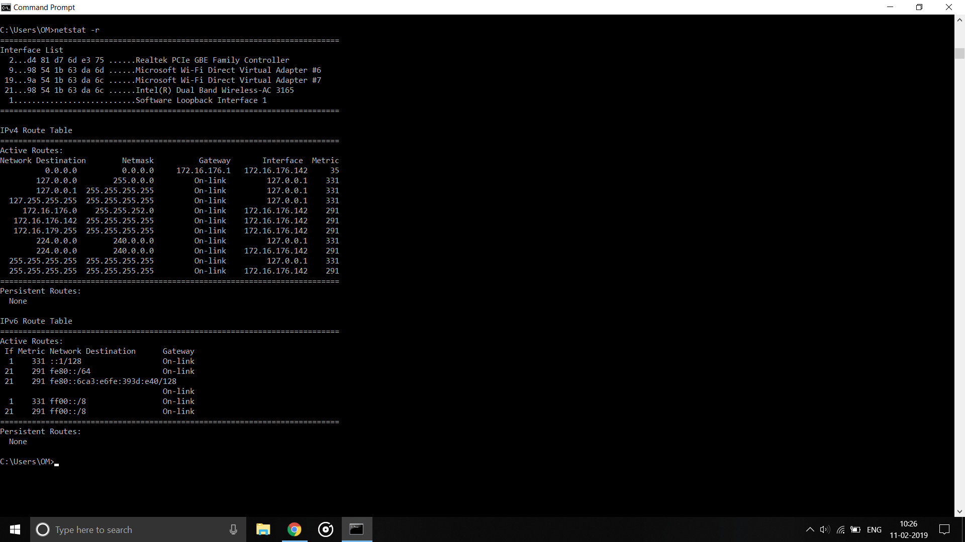

**Practical 5**

**Aim : Network Topologies**

**Types of Network Topology**

Network Topology is the schematic description of a network arrangement, connecting various nodes(sender and receiver) through lines of connection.

## **BUS Topology**

Bus topology is a network type in which every computer and network device is connected to single cable. When it has exactly two endpoints, then it is called **Linear Bus topology**.

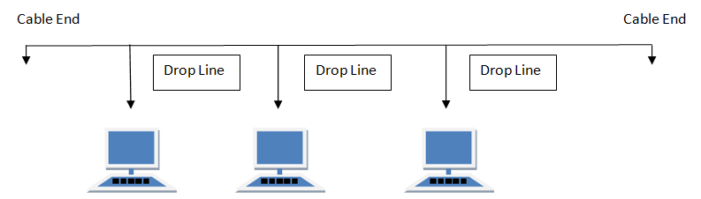

#### **Features of Bus Topology**

1. It transmits data only in one direction.
2. Every device is connected to a single cable

#### **Advantages of Bus Topology**

1. It is cost effective.
2. Cable required is least compared to other network topology.
3. Used in small networks.
4. It is easy to understand.
5. Easy to expand joining two cables together.

#### **Disadvantages of Bus Topology**

1. Cables fails then whole network fails.
2. If network traffic is heavy or nodes are more the performance of the network decreases.
3. Cable has a limited length.
4. It is slower than the ring topology.

## **RING Topology**

It is called ring topology because it forms a ring as each computer is connected to another computer, with the last one connected to the first. Exactly two neighbors for each device.

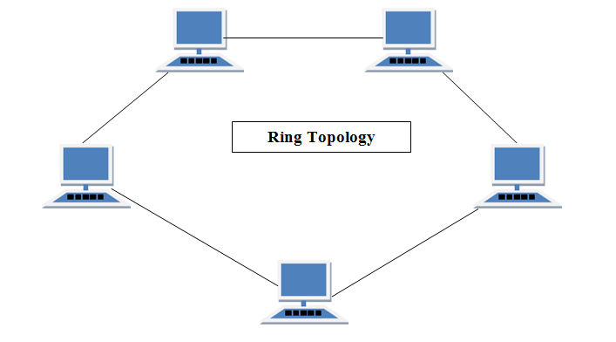

#### **Features of Ring Topology**

1. A number of repeaters are used for Ring topology with large number of nodes, because if someone wants to send some data to the last node in the ring topology with 100 nodes, then the data will have to pass through 99 nodes to reach the 100th node. Hence to prevent data loss repeaters are used in the network.
2. The transmission is unidirectional, but it can be made bidirectional by having 2 connections between each Network Node, it is called **Dual Ring Topology**.
3. In Dual Ring Topology, two ring networks are formed, and data flow is in opposite direction in them. Also, if one ring fails, the second ring can act as a backup, to keep the network up.
4. Data is transferred in a sequential manner that is bit by bit. Data transmitted, has to pass through each node of the network, till the destination node.

#### **Advantages of Ring Topology**

1. Transmitting network is not affected by high traffic or by adding more nodes, as only the nodes having tokens can transmit data.
2. Cheap to install and expand

#### **Disadvantages of Ring Topology**

1. Troubleshooting is difficult in ring topology.
2. Adding or deleting the computers disturbs the network activity.
3. Failure of one computer disturbs the whole network.

## **STAR Topology**

In this type of topology all the computers are connected to a single hub through a cable. This hub is the central node and all others nodes are connected to the central node.

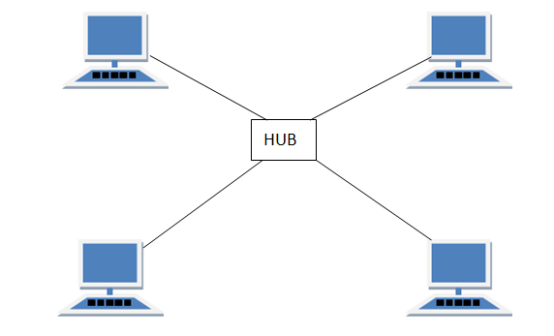

#### **Features of Star Topology**

1. Every node has its own dedicated connection to the hub.
2. Hub acts as a repeater for data flow.
3. Can be used with twisted pair, Optical Fibre or coaxial cable.

#### **Advantages of Star Topology**

1. Fast performance with few nodes and low network traffic.
2. Hub can be upgraded easily.
3. Easy to troubleshoot.
4. Easy to setup and modify.
5. Only that node is affected which has failed, rest of the nodes can work smoothly.

#### **Disadvantages of Star Topology**

1. Cost of installation is high.
2. Expensive to use.
3. If the hub fails then the whole network is stopped because all the nodes depend on the hub.
4. Performance is based on the hub that is it depends on its capacity

## **MESH Topology**

It is a point-to-point connection to other nodes or devices. All the network nodes are connected to each other. Mesh has n(n-1)/2 physical channels to link n devices.

There are two techniques to transmit data over the Mesh topology, they are :

1. Routing
2. Flooding

### **MESH Topology: Routing**

In routing, the nodes have a routing logic, as per the network requirements. Like routing logic to direct the data to reach the destination using the shortest distance. Or, routing logic which has information about the broken links, and it avoids those node etc. We can even have routing logic, to re-configure the failed nodes.

### **MESH Topology: Flooding**

In flooding, the same data is transmitted to all the network nodes, hence no routing logic is required. The network is robust, and the its very unlikely to lose the data. But it leads to unwanted load over the network.

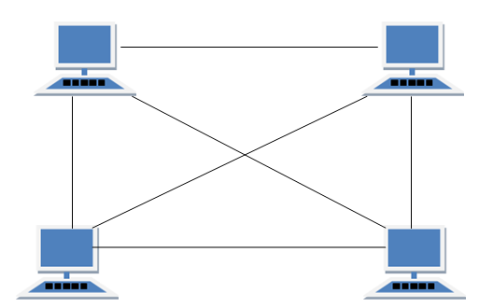

#### 

#### **Types of Mesh Topology**

1. **Partial Mesh Topology :** In this topology some of the systems are connected in the same fashion as mesh topology but some devices are only connected to two or three devices.
2. **Full Mesh Topology :** Each and every nodes or devices are connected to each other.

#### **Features of Mesh Topology**

1. Fully connected.
2. Robust.
3. Not flexible.

#### **Advantages of Mesh Topology**

1. Each connection can carry its own data load.
2. It is robust.
3. Fault is diagnosed easily.
4. Provides security and privacy.

#### **Disadvantages of Mesh Topology**

1. Installation and configuration is difficult.
2. Cabling cost is more.
3. Bulk wiring is required.

## **TREE Topology**

It has a root node and all other nodes are connected to it forming a hierarchy. It is also called hierarchical topology. It should at least have three levels to the hierarchy.

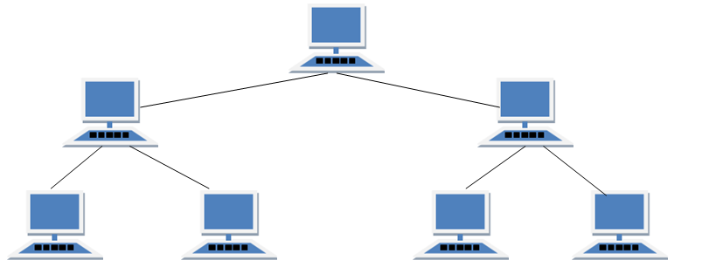

#### **Features of Tree Topology**

1. Ideal if workstations are located in groups.
2. Used in Wide Area Network.

#### **Advantages of Tree Topology**

1. Extension of bus and star topologies.
2. Expansion of nodes is possible and easy.
3. Easily managed and maintained.
4. Error detection is easily done.

#### **Disadvantages of Tree Topology**

1. Heavily cabled.
2. Costly.
3. If more nodes are added maintenance is difficult.
4. Central hub fails, network fails.

## **HYBRID Topology**

It is two different types of topologies which is a mixture of two or more topologies. For example if in an office in one department ring topology is used and in another star topology is used, connecting these topologies will result in Hybrid Topology (ring topology and star topology).

#### **Features of Hybrid Topology**

1. It is a combination of two or topologies
2. Inherits the advantages and disadvantages of the topologies included

#### **Advantages of Hybrid Topology**

1. Reliable as Error detecting and troubleshooting is easy.
2. Effective.
3. Scalable as size can be increased easily.
4. Flexible.

#### **Disadvantages of Hybrid Topology**

1. Complex in design.
2. Costly.

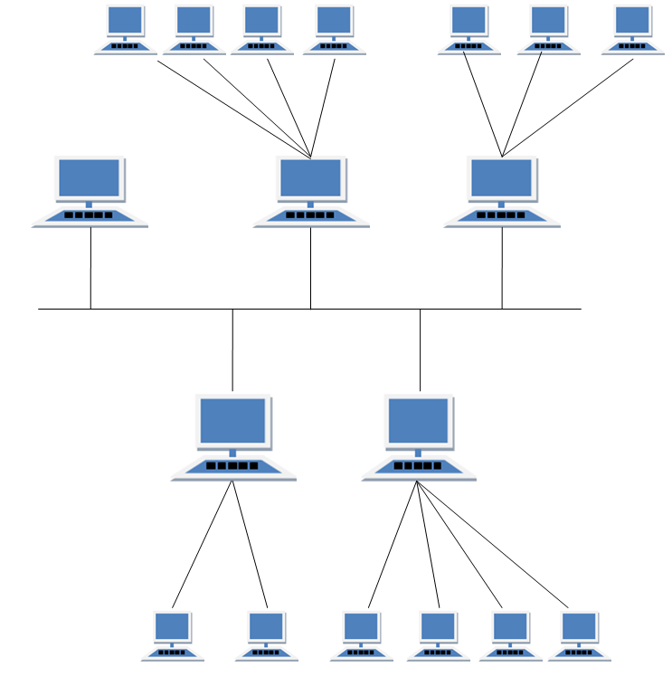

**Practical 6**

**Aim : Network Sharing**

Over the years, Wi-Fi has grown tremendously but sharing huge files or for that matter, a whole drive is still not efficient. You get cramped up speed and your data is running through a public channel. I would any day prefer sharing a drive or transferring data over LAN cable. On that note, the following is the step by step guide to transfer files between PC’s using an Ethernet cable.

Sharing file using LAN cable through the following steps:

1. Connect both PCs with LAN cable
2. Open Control Panel first

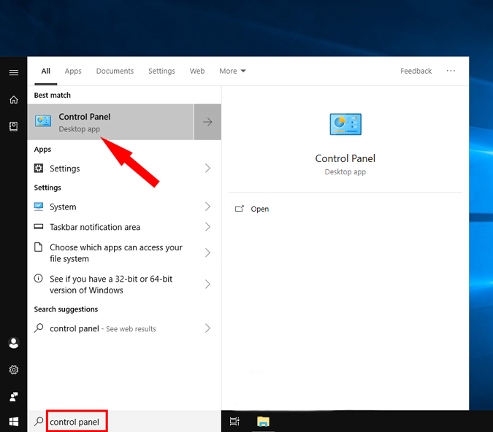

1. Open Network and Internet in control panel

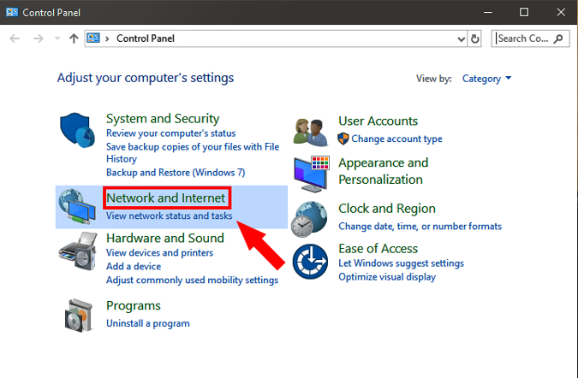

1. Open Network and Sharing Center

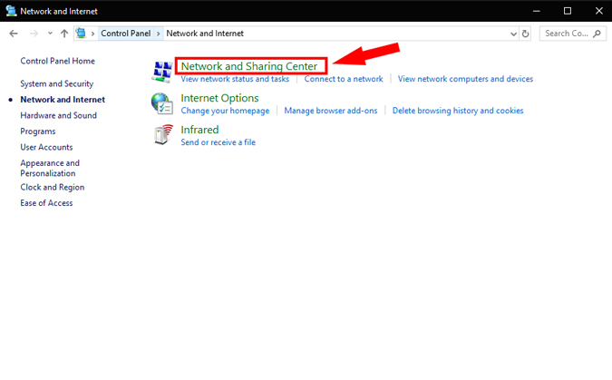

1. Change Advanced sharing settings

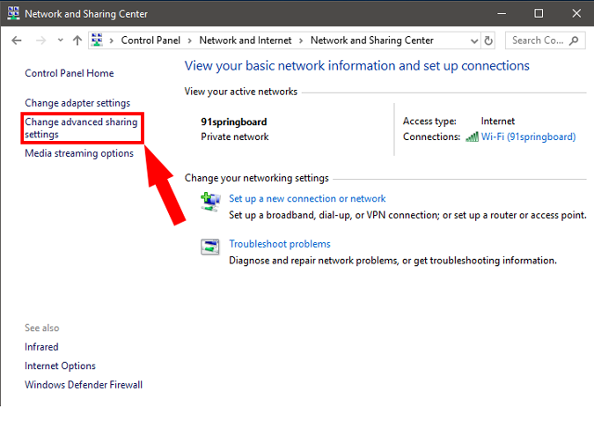

1. Click on All Networks

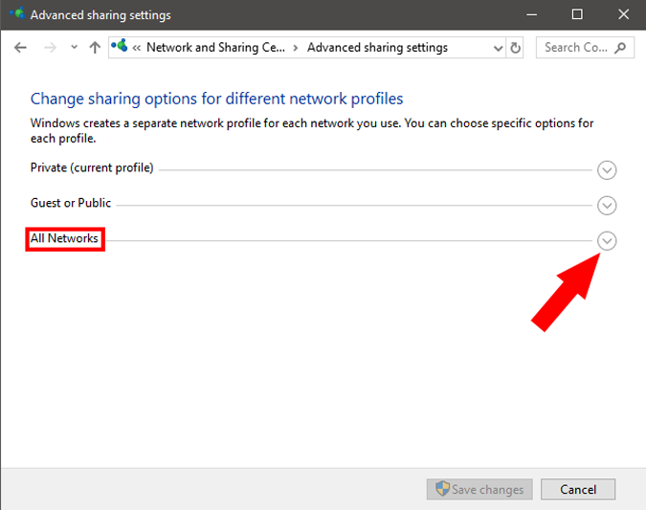

1. Change the required settings and save them

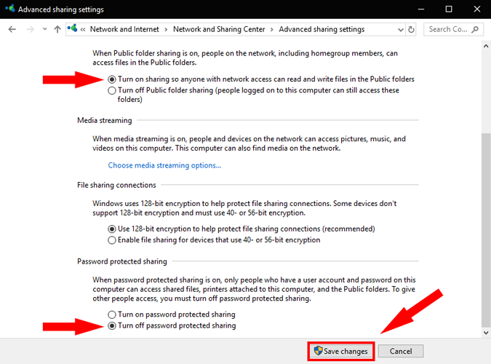

1. Go to the network and sharing center again

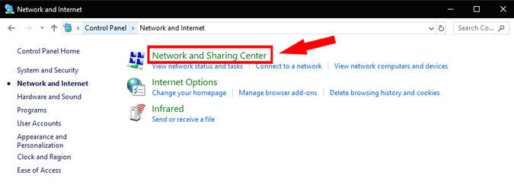

1. Change the properties of the ethernet connection on both the computers

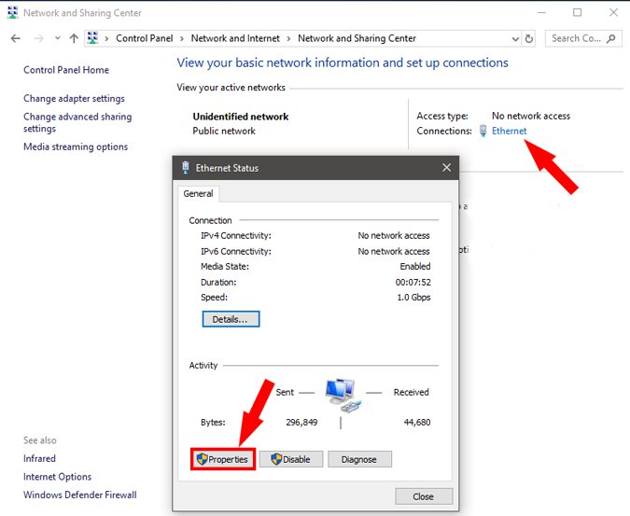

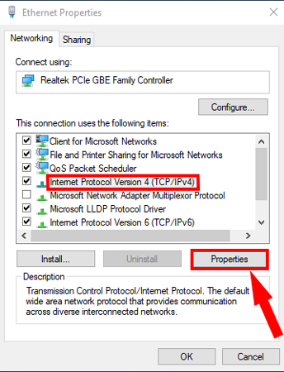

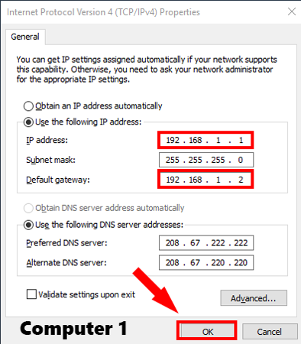 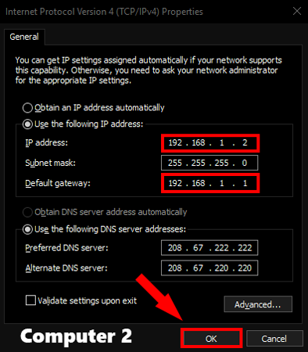

1. Open Network in file explorer then network

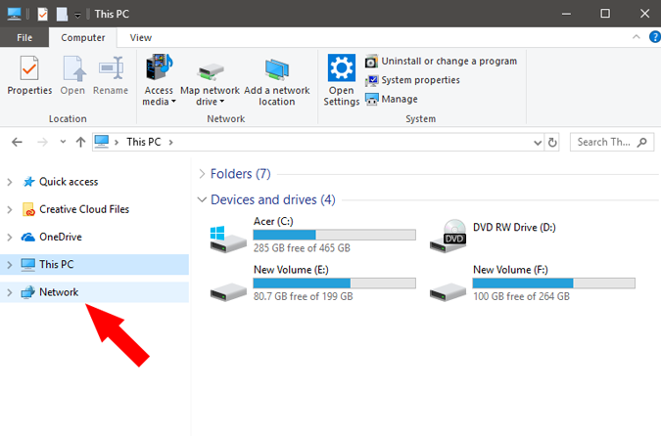

1. See the connected systems and share the files among the connected devices

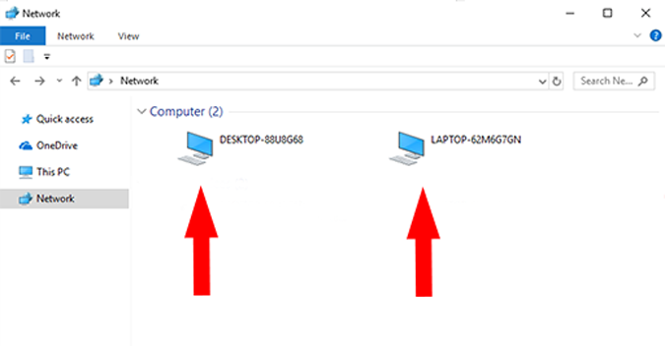

**Practical 7**

**Aim : Hamming Distance Code**

**Code :**

#!/usr/bin/env python

str1 = str(input("Enter the Correct String :"))

str2 = str(input("Enter the Wrong String :"))

str1 = list(str1)

str2 = list(str2)

count = abs(len(str1) - len(str2))

for i in range(min(len(str1),len(str2))):

if not str1[i] == str2[i]:

count += 1

print("The hamming distance between the strings is :",count)

**Output :**

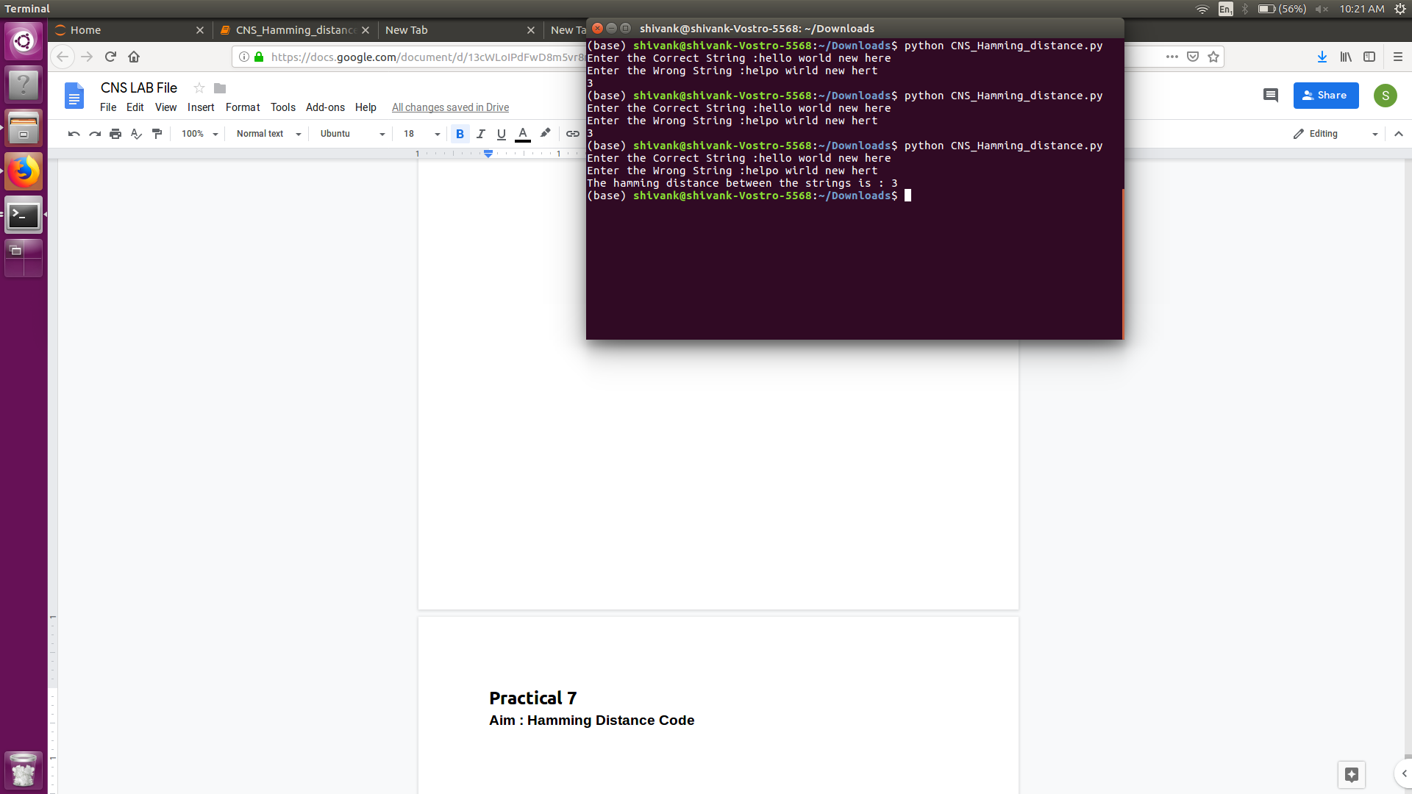

**Practical 8**

**Aim : Checksum Code**

**Code :**

#!/usr/bin/env python

#function for sum of two data elements

def sum_binary(x1,x2,len_val):

sumv = ''

c ='0'

for i in range(len_val-1,-1,-1):

if x1[i] == x2[i] == c == '1':

sumv = '1' + sumv

c = ‘1'

elif x1[i] == x2[i] == '1':

sumv = '0' + sumv

c = '1’

elif x1[i] == x2[i] == c == '0':

sumv = '0' + sumv

c = '0’

elif x1[i] == x2[i] == '0':

sumv = '1' + sumv

c = '0’

elif (not x1[i] == x2[i]) and c=='1':

sumv = '0' +sumv

c = '1’

elif (not x1[i] == x2[i]) and c=='0':

sumv = '1' +sumv

c = '0’

return sumv

#function for complement of data elements

def complement(x,len_val):

t=''

for i in range(len_val):

if x[i] == '0':

t+='1’

else:

t+='0'

return t

#function for converting data elements into specific size from input stream

def bit_data(data,d_size):

b_data =[]

for i in range(int(len(data)/d_size)):

b_data.append(data[i*d_size:(i+1)*d_size])

c='’

for i in range(d_size):

c+='0'

return b_data,c

#taking input data

data = str(input("Enter bit stream :"))

data_size = int(input("Enter Checksum Length :"))

byte_data,checksum = bit_data(data,data_size)

print('Data for checksum',byte_data)

#evaluating checksum

for i in byte_data:

checksum = sum_binary(i,checksum,len(i))

checksum = complement(checksum,len(checksum))

print("Checksum for the given data is :",checksum)

**Output :** 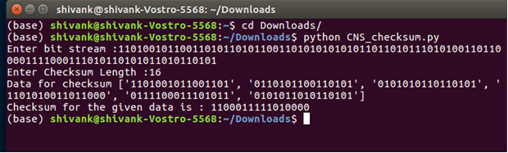

**Practical 9**

**Aim : Program for Sliding Window Protocol**

1. **Go Back N**
2. **Selective Repeat**

**Go Back N**

**Code:**

import random

packets = [ 'a', 'b', 'c', 'd', 'e', 'f', 'g', 'h', 'i', 'j', 'k', 'l', 'm', 'n']

window_size = 5

window = []

print("Packets to be sent :",packets)

print("Window Size :",window_size)

i=0

while( i<(len(packets)) ):

t=i+window_size

if t>=len(packets):

t = len(packets)

window = packets[i:t]

ack = random.randint(1,window_size+1)

if i+ack>len(packets):

ack = len(packets)-i+1

print("Acknowledgement Recieved :",ack)

print("Packets Recieved :", window[0:ack-1])

i+=ack-1

**Output :**

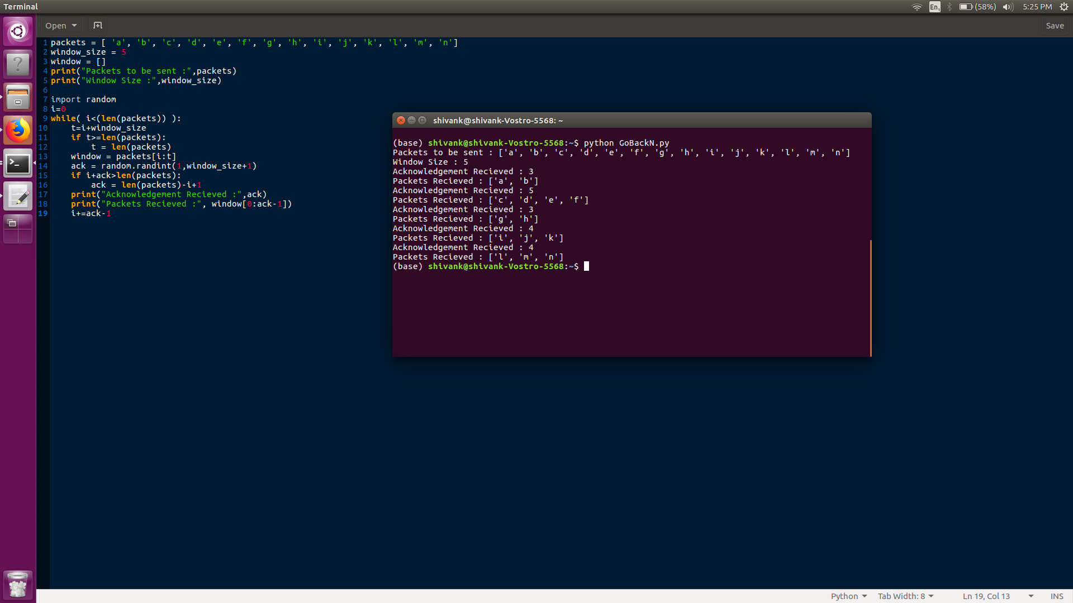

**Selective repeat**

**Code :**

import random

packets = [ 'n', 'm', 'l', 'k', 'j', 'i', 'h', 'g', 'f', 'e', 'd', 'c', 'b', 'a']

window_size = 5

window = []

print("Packets to be sent :",packets)

print("Window Size :",window_size)

i=0

fl = 0

nr = 0

while( packets ):

while(len(packets)>0 and len(window)<window_size):

window.append(packets[0])

packets.remove(packets[0])

ack = random.randint(1,window_size+1)

if ack>len(packets):

fl = 1

ack = len(window)+1

if not ack == 1:

nack = random.randint(1,ack-1)

if fl == 1:

nack = -1

if nack == -1:

print("Acknowledgement Recieved :",ack)

print("No negative Acknowledgement")

print("Packets Recieved :", window[0:ack-1])

for i in range(ack-1):

window.remove(window[0])

nr = 0

else:

print("Acknowledgement Recieved :",ack)

print("Negative Acknowledgement Recieved :",nack)

not_recieved = window[nack]

window.remove(not_recieved)

print("Packets Recieved :", window[0:ack-2])

for i in range(ack-2):

window.remove(window[0])

window.insert(0,not_recieved)

nr = 1

**Output :**

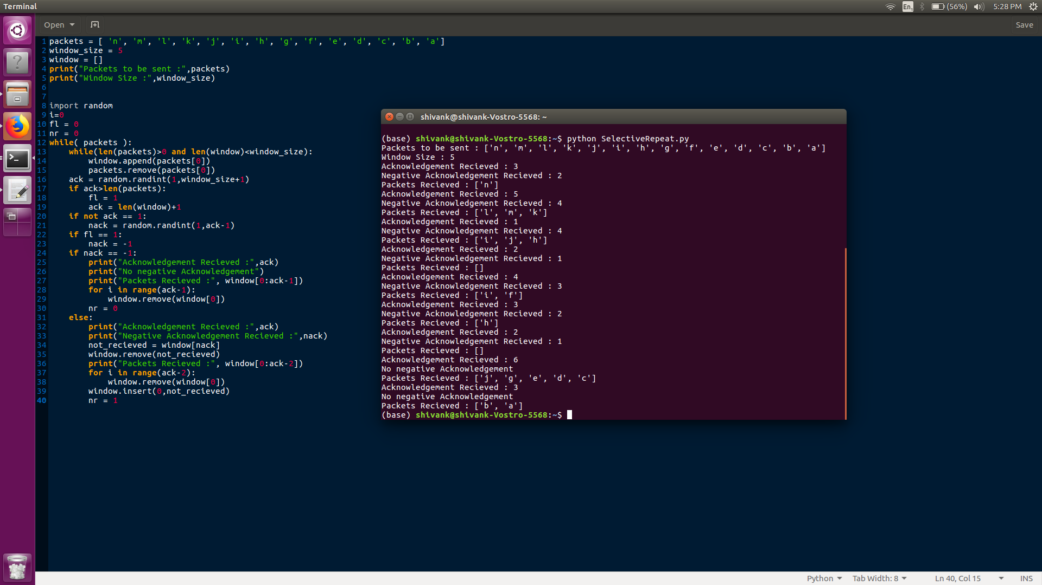

**Practical 10**

**Aim : Program for Distance Vector routing algorithm**

**Code :**

graph = [[ 0, 3, 2, 4],

[ 3, 0, 2,-1],

[ 2, 2, 0, 1],

[ 4,-1, 1, 0]]

nodes = [0,1,2,3]

maxint = 100000

def distance_vector(start,end):

distance = [maxint]*len(nodes)

distance[start] = 0

visited = [False]*len(nodes)

visited[start]=True

cur = start

for j in range(len(nodes)):

for i in nodes:

if not graph[cur][i] == -1:

if graph[cur][i] + distance[cur] < distance[i]:

distance[i] = graph[cur][i] + distance[cur]

minval = maxint

for i in nodes:

if distance[i] < minval and (not visited[i]):

minval = distance[i]

cur = i

visited[cur] = True

print("Distance Between ",start," and ",end," is :", distance[end])

start = int(input("Enter the starting node : "))

end = int(input("Enter the ending node : "))

distance_vector(start,end)

**Output :**

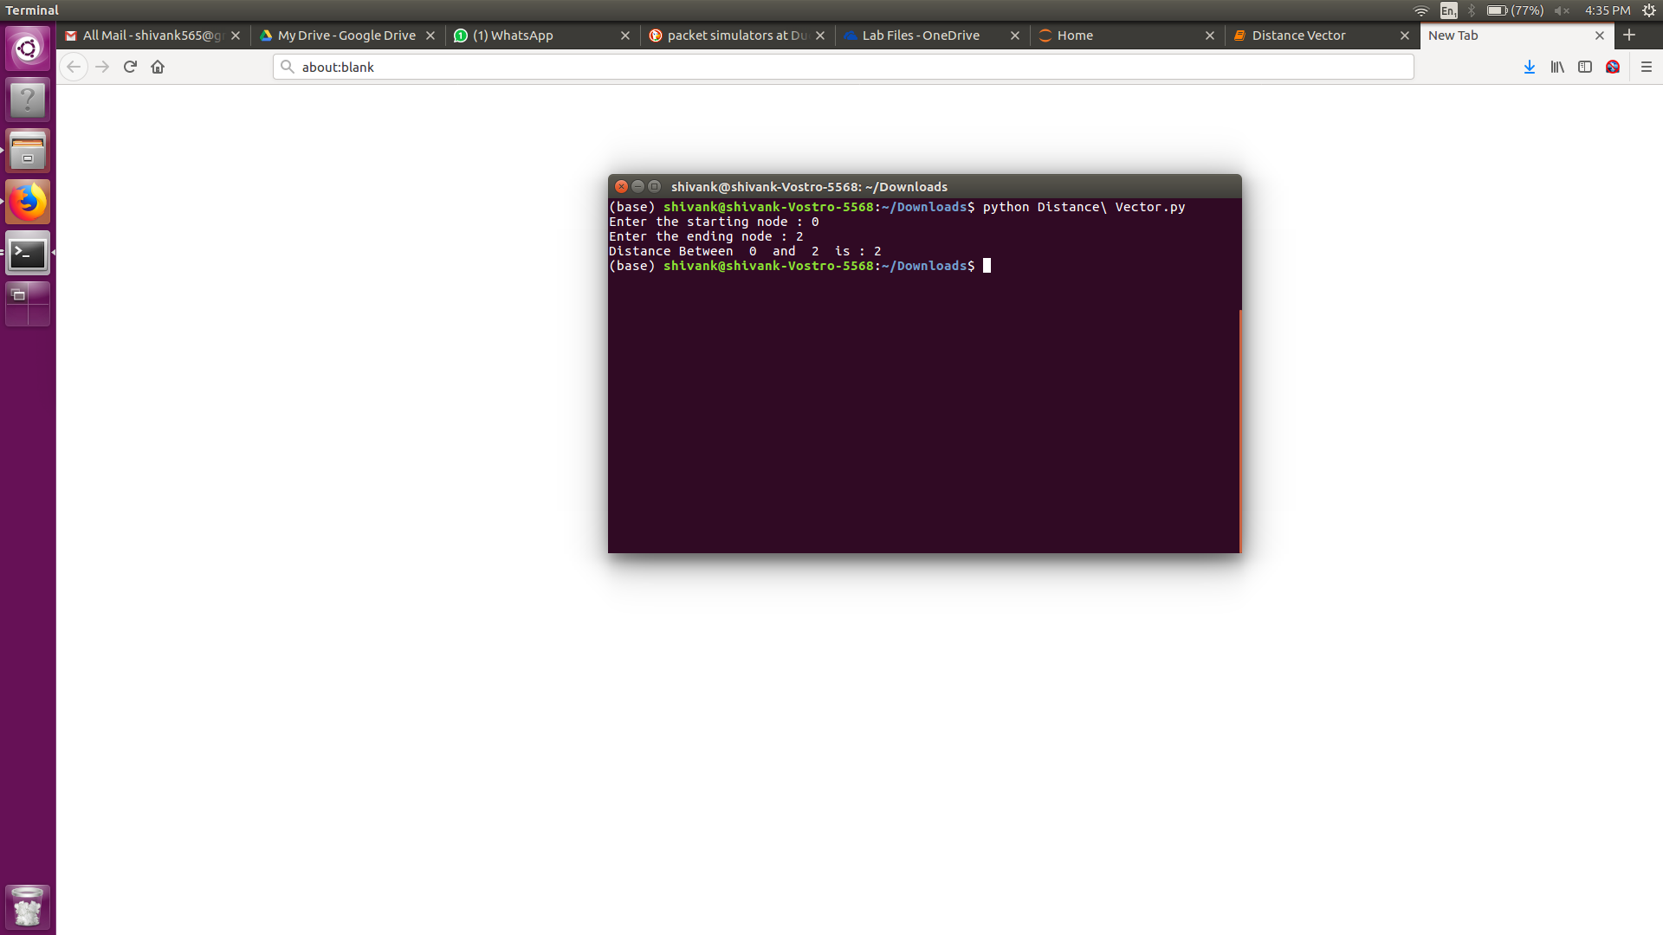

**Practical 11**

**Aim : *To study the various IEEE Standards- IEEE 802.3,IEEE 802.11, IEEE 802.16***

**Ethernet formats**

There is a convention for describing the different forms of Ethernet. For example 10Base-T and 100Base-T are widely seen in the technical articles and literature. The designator consists of three parts:

* The first number (typically one of 10, 100, or 1000) indicates the transmission speed in megabits per second.
* The second term indicates transmission type: BASE = baseband; BROAD = broadband.
* The last number indicates segment length. A 5 means a 500-meter (500-m) segment length from original Thicknet. In the more recent versions of the IEEE 802.3 standard, letters replace numbers. For example, in 10BASE-T, the T means unshielded twisted-pair cables. Further numbers indicate the number of twisted pairs available. For example in 100BASE-T4, the T4 indicates four twisted pairs.

**IEEE 802.3**

It is a working group and a collection of Institute of Electrical and Electronics Engineers (IEEE) standards produced by the working group defining the physical layer and data link layer's media access control (MAC) of wired Ethernet. This is generally a local area network (LAN) technology with some wide area network (WAN) applications. Physical connections are made between nodes and/or infrastructure devices (hubs, switches, routers) by various types of copper or fibre cable.

802.3 is a technology that supports the IEEE 802.1 network architecture.

802.3 also defines LAN access method using CSMA/CD.

The Ethernet IEEE 802.3 LAN can be considered to consist of two main elements:

* **Interconnecting media:**   The media through which the signals propagate is of great importance within the Ethernet network system. It governs the majority of the properties that determine the speed at which the data may be transmitted. There are a number of options that may be used.
  + Coaxial cable:   This was one of the first types of interconnecting media to be used for Ethernet. Typically, the characteristic impedance was around 110 ohms and therefore the cables normally used for radio frequency applications were not applicable.
  + Twisted Pair Cables   Type types of twisted pair may be used: Unshielded Twisted Pair (UTP) or a Shielded Twisted Pair (STP). Generally, the shielded types are better as they limit stray pickup more and therefore data errors are reduced.
  + Fibre optic cable:   Fibre optic cable is being used increasingly as it provides very high immunity to pick up and radiation as well as allowing very high data rates to be communicated.
* **Network nodes:** The network nodes are the points to and from which the communication takes place. The network nodes also fall into categories:
* Data Terminal Equipment - DTE:   These devices are either the source or destination of the data being sent. Devices such as PCs, file servers, print servers and the like fall into this category.
* Data Communications Equipment - DCE:   Devices that fall into this category receive and forward the data frames across the network, and they may often be referred to as 'Intermediate Network Devices' or Intermediate Nodes. They include items such as repeaters, routers, switches or even modems and other communications interface units.

**Ethernet network topologies**

There are several network topologies that can be used for Ethernet communications. The actual form used will depend upon the requirements.

* **Point to point:**   This is the simplest configuration as only two network units are used. It may be a DTE to DTE, DTE to DCE, or even a DCE to DCE. In this simple structure the cable is known as the network link. Links of this nature are used to transport data from one place to another and where it is convenient to use Ethernet as the transport mechanism.
* **Coaxial bus:**   This type of Ethernet network is rarely used these days. The systems used a coaxial cable where the network units were located along the length of the cable. The segment lengths were limited to a maximum of 500 metres, and it was possible to place up to 1024 DTEs along its length. Although this form of network topology is not installed these days, a very few legacy systems might just still be in use.
* **Star network:**   This type of Ethernet network has been the dominant topology since the early 1990s. It consists of a central network unit, which may be what is termed a multi-port repeater or hub, or a network switch. All the connections to other nodes radiate out from this and are point to point links.

**IEEE 802.11**

Wi-Fi wireless connectivity is an established part of everyday life. All smartphones have it incorporated into the phone enabling low cost connectivity to be provided. In addition to this, computers, laptops, tablets, cameras and very many other devices use Wi-Fi including many Internet of Things, IoT sensors and nodes.

To enable different items incorporating wireless technology like this to communicate with each other, common standards are needed. The standard for Wi-Fi is the IEEE 802.11 standard.

There are two types of WLAN network that can be formed using a WiFi system: infrastructure networks; and ad-hoc networks.

The infrastructure application is aimed at office areas or to provide a "hotspot". The WLAN equipment can be installed instead of a wired system, and can provide considerable cost savings, especially when used in established offices. A backbone wired network is still required and is connected to a server. The wireless network is then split up into a number of cells, each serviced by a base station or Access Point (AP) which acts as a controller for the cell. Each Access Point may have a range of between 30 and 300 metres dependent upon the environment and the location of the Access Point.

The other type of network that may be used is termed an Ad-Hoc network. These are formed when a number of computers and peripherals are brought together. They may be needed when several people come together and need to share data or if they need to access a printer without the need for having to use wire connections. In this situation the users only communicate with each other and not with a larger wired network. As a result there is no Access Point and special algorithms within the protocols are used to enable one of the peripherals to take over the role of master to control the network with the others acting as slaves.

**WiFi hotspots**

One of the advantages of using WiFi IEEE 802.11 is that it is possible to connect to the Internet when out and about. Public WiFi access is everywhere - in cafes, hotels, airports, and very many other places.

Sometimes all that is required is to select a network and press the connect button. Others require a password to be entered.

When using public Wi_Fi networks it is essential to act wisely because it is very easy for hackers to gain access and see exactly what you are sending: user names, passwords, credit card credentials, etc. If the network does not sue encryption, then all the data can be seen by potential hackers.

* **Locating a Wi-Fi router:**   The performance of a Wi-Fi router can be very dependent upon its location. Place it badly and it will not be able to perform as well. By locating a router in the best position, much better performance can be gained.
* **Installing and setting up a Wi-Fi router:**   Normally Wi-Fi routers are very easy to set up. Much work has been undertaken in recent years to ensure they are very easy to install and set up.
* **Using Hotspots securely:**   Wi-Fi hotspots are everywhere, but if they are used without taking precautions, they can present an ideal opportunity for hackers to gain valuable passwords and credit card credentials.
* **Wi-Fi variants:**   There are several different forms of Wi-Fi. The first that were widely available were IEEE802.11a and 802.11b. These have long been superseded with a variety of variants offering much higher speeds and generally better levels of connectivity.

They are the world's most widely used wireless computer networking standards, used in most home and office networks to allow laptops, printers, and smartphones to talk to each other and access the Internet without connecting wires. They are created and maintained by the Institute of Electrical and Electronics Engineers (IEEE) LAN/MAN Standards Committee (IEEE 802). The base version of the standard was released in 1997, and has had subsequent amendments. The standard and amendments provide the basis for wireless network products using the Wi-Fi brand. While each amendment is officially revoked when it is incorporated in the latest version of the standard, the corporate world tends to market to the revisions because they concisely denote capabilities of their products. As a result, in the marketplace, each revision tends to become its own standard.

The protocols are typically used in conjunction with IEEE 802.2, and are designed to interwork seamlessly with Ethernet, and are very often used to carry Internet Protocol traffic.

**IEEE 802.11 Standards**

There is a plethora of standards under the IEEE 802 LMSC (LAN / MAN Standards Committee). Of these even 802.11 has a variety of standards, each with a letter suffix. These cover everything from the wireless standards themselves, to standards for security aspects, quality of service and the like:

* **802.11a:**   This was the first WiFi standard and was for the wireless network bearer operating in the 5 GHz ISM band with data rate up to 54 Mbps.
* **802.11b:**   Wireless network bearer operating in the 2.4 GHz ISM band with data rates up to 11 Mbps.
* **802.11e:**   This WiFi standard provides for quality of service and prioritization.
* **802.11f:**   This WiFI standard addresses the issue of WiFi handover
* **802.11g:**   Wireless network bearer operating in 2.4 GHz ISM band with data rates up to 54 Mbps.
* **802.11h:**   Power control
* **802.11i:**   Security - this standard defines the security, authentication and encryption used within Wi-Fi networks.
* **802.11j:**   Interworking
* **802.11k:**   Measurement reporting
* **802.11n:**   Wireless network bearer operating in the 2.4 and 5 GHz ISM bands with data rates up to 600 Mbps.
* **802.11s:**   Mesh networking
* **802.11u:**   Roaming and Hotspot 2.0.
* **802.11ac:**   Wireless network bearer operating below 6GHz to provide data rates of at least 1Gbps per second for multi-station operation and 500 Mbps on a single link.
* **802.11ad:**   Wireless network bearer providing very high throughput at frequencies up to 60GHz.
* **802.11af:**   Wi-Fi in TV spectrum white spaces (often called White-Fi).
* **802.11ah:**   Wi-Fi using unlicensed spectrum below 1 GHz to provide long range communications and support for the Internet of Everything.
* **802.11ax:**   802.11ax is seen as the future successor to 802.11ac. Using technologies including OFDMA, MU-MIMO and others its aim is to increase spectral efficiency and hence the overall usability.

**IEEE 802.16**

802.16 is a group of broadband wireless communications standards for metropolitan area networks (MANs) developed by a working group of the Institute of Electrical and Electronics Engineers (IEEE). The original 802.16 standard, published in December 2001, specified fixed point-to-multipoint broadband wireless systems operating in the 10-66 GHz licensed spectrum. An amendment, 802.16a, approved in January 2003, specified non-line-of-sight extensions in the 2-11 GHz spectrum, delivering up to 70 Mbps at distances up to 31 miles. Officially called the WirelessMAN™ specification, 802.16 standards are expected to enable multimedia applications with wireless connection and, with a range of up to 30 miles, provide a viable last mile technology.

A coalition of wireless industry companies, including Intel, Proxim and Nokia, banded together in April 2001 to form WiMAX, an 802.16 advocacy group. The organization's purpose is to actively promote and certify compatibility and interoperability of devices based on the 802.16 specification, and to develop such devices for the marketplace. According to the WiMAX Forum, the first products based on 802.16 technology are expected to hit the market in 2004.

Wireless means transmitting signals using radio waves as the medium instead of wires. Wireless technologies are used for tasks as simple as switching off the television or as complex as supplying the sales force with information from an automated enterprise application while in the field. Now cordless keyboards and mice, PDAs, pagers and digital and cellular phones have become part of our daily life.

Some of the inherent characteristics of wireless communications systems which make it attractive for users, are given below −

* **Mobility** − A wireless communications system allows users to access information beyond their desk and conduct business from anywhere without having a wire connectivity.
* **Reachability** − Wireless communication systems enable people to be stay connected and be reachable, regardless of the location they are operating from.
* **Simplicity** − Wireless communication system are easy and fast to deploy in comparison of cabled network. Initial setup cost could be a bit high but other advantages overcome that high cost.
* **Maintainability** − In a wireless system, you do not have to spend too much cost and time to maintain the network setup.
* **Roaming Services** − Using a wireless network system, you can provide service anywhere any time including train, buses, aeroplanes etc.
* **New Services** − Wireless communication systems provide various smart services like SMS and MM

**What is WiMAX ?**

WiMAX is one of the hottest broadband wireless technologies around today. WiMAX systems are expected to deliver broadband access services to residential and enterprise customers in an economical way.

Loosely, WiMax is a standardized wireless version of Ethernet intended primarily as an alternative to wire technologies (such as Cable Modems, DSL and T1/E1 links) to provide broadband access to customer premises.

More strictly, WiMAX is an industry trade organization formed by leading communications, component, and equipment companies to promote and certify compatibility and interoperability of broadband wireless access equipment that conforms to the IEEE 802.16 and ETSI HIPERMAN standards.

WiMAX would operate similar to WiFi, but at higher speeds over greater distances and for a greater number of users. WiMAX has the ability to provide service even in areas that are difficult for wired infrastructure to reach and the ability to overcome the physical limitations of traditional wired infrastructure.

WiMAX was formed in April 2001, in anticipation of the publication of the original 10-66 GHz IEEE 802.16 specifications. WiMAX is to 802.16 as the WiFi Alliance is to 802.11.

**WiMAX is**

* Acronym for **Worldwide Interoperability for Microwave Access**.
* Based on Wireless MAN technology.
* A wireless technology optimized for the delivery of IP centric services over a wide area.
* A scalable wireless platform for constructing alternative and complementary broadband networks.
* A certification that denotes interoperability of equipment built to the IEEE 802.16 or compatible standard. The IEEE 802.16 Working Group develops standards that address two types of usage models −
  + A fixed usage model (IEEE 802.16-2004).
  + A portable usage model (IEEE 802.16e).

**WiMAX Goals**

A standard by itself is not enough to enable mass adoption. WiMAX has stepped forward to help solve barriers to adoption, such as interoperability and cost of deployment. WiMAX will help ignite the wireless MAN industry by defining and conducting interoperability testing and labelling vendor systems with a "WiMAX Certified™" label once testing has been completed successfully.

**Two Type of Services**

WiMAX can provide two forms of wireless service −

* **Non-line-of-sight** − service is a WiFi sort of service. Here a small antenna on your computer connects to the WiMAX tower. In this mode, WiMAX uses a lower frequency range -- 2 GHz to 11 GHz (similar to WiFi).
* **Line-of-sight** − service, where a fixed dish antenna points straight at the WiMAX tower from a rooftop or pole. The line-of-sight connection is stronger and more stable, so it's able to send a lot of data with fewer errors. Line-of-sight transmissions use higher frequencies, with ranges reaching a possible 66 GHz.
* WiMAX is based on a very flexible and robust air interface defined by the IEEE 802.16 group.
* WiMAX is similar to the wireless standard known as Wi-Fi, but on a much larger scale and at faster speeds.
* The WiMAX physical layer is based on OFDM, which is an elegant and effective technique for overcoming multipath distortion.
* The physical layer supports several advanced techniques for increasing the reliability of the link layer. These techniques include powerful error correction coding, including turbo coding and LDPC, hybrid-ARQ, and antenna arrays.
* WiMAX supports a number of advanced signal-processing techniques to improve overall system capacity. These techniques include adaptive modulation and coding, spatial multiplexing, and multiuser diversity.
* WiMAX has a very flexible MAC layer that can accommodate a variety of traffic types, including voice, video, and multimedia, and provide strong QoS.
* Robust security functions, such as strong encryption and mutual authentication, are built into the WiMAX standard.
* WiMAX defines a flexible all-IP-based network architecture that allows for the exploitation of all the benefits of IP.
* WiMAX offers very high spectral efficiency, particularly when using higher-order MIMO solutions.

WiMAX Forum™ is an industry-led, non-profit corporation formed to promote and certify compatibility and interoperability of broadband wireless products.

WiMAX Forum Certified™ products are based on a single global standard IEEE 802.16 enabling complete interoperability worldwide.